**CAKE N BAKE**

## INTERNSHIP REPORT

***Submitted by***

# MIHIR CHAMPAKBHAI PATEL

## 161230107040

***In fulfillment for the award of the degree of***

# BACHELOR OF ENGINEERING

***in***

## Computer Engineering

**S. S. Agrawal Institute of Engineering & Technology, Navsari**



# Gujarat Technological University, Ahmedabad

### April-May, 2022

 

**S. S. Agrawal Institute Of Engineering & Technology, Navsari**

### Veeranjali Marg , Near Devina Park Socirty, Gandevi,Navsari Pin: 396445

CERTIFICATE

This is to certify that the internship report submitted along with the internship entitled **CAKE N BAKE** has been carried out by **MIHIR CHAMPAKBHAI PATEL** under my guidance in partial fulfillment for the degree of Bachelor of Engineering in Computer Engineering, 8th Semester of Gujarat Technological University, Ahmedabad during the academic year 2021-22.

Prof. Farheenbanu Mansur Prof. Brijesh Bhandari

Internal Guide Head of the Department

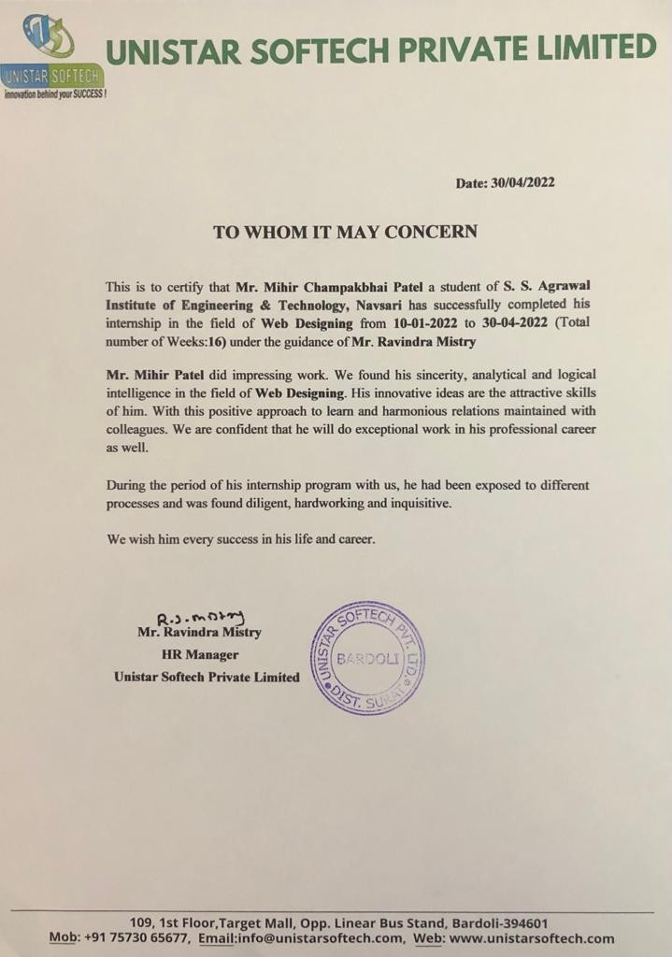

 

## S. S. Agrawal Institute Of Engineering & Technology, Navsari

### Veeranjali Marg , Near Devina Park Socirty, Gandevi , Navsari Pin: 396445

DECLARATION

I hereby declare that the Internship report submitted along with the Internship entitled CAKE N BAKE submitted in partial fulfillment for the degree of Bachelor of Engineering in Computer Engineering to Gujarat Technological University , Ahmedabad , is a bonafide record of original internship/project work carried out by me at Unistar Softech Private limited under the supervision of Mr. Ravindra Mistry and that no part of this report has been directly copied from any students’ reports or taken from any other source, without providing due reference.

Name of the Student Sign of Student

1. Mihir Champakbhai Patel

# Acknowledgement

It gives me great pleasure in submitting this project entitled “Cake n Bake” as a part of the curriculum of BE (Semester VIII).I avail this opportunity to express my heartfelt gratitude to a number of people who extends their full support and co-operation in developing this project. I would like to take opportunity to thank my college, S. S. Agrawal Institute of Engineering & Technology, Navsari.

I am thankful to my internal project **PROF. ANALI D. SHAH** has been an exceptional Madam and motivator. Her inspirational ideas and advices have kept me going during the training period. I am thankful to the faculty of the institute for their constant guidance not only during training period but also throughout college career.

Finally, I would like to thank My Parents for their support throughout the project. I owe a special debt to our family & friends for their support blessing and encouragement for me.

**Mihir Champakbhai Patel**

**Abstract**

Cake shop is an establishment that sells flour and cream-based food baked in oven such as Bread, cake, patties etc and provide services for special occasion such as wedding, birthday parties, anniversaries or even business events cake shop can provide a wide range of assorted cake in different design. When baked goods like cakes are ready to sell it is essential, they earn your customers attention and the product need to look good enough test presenting an attractive dietary is one way to garner that virtual appeal from customers and passer-by. Pastries, Rusks, Bread, Cakes, Toffees etc. comes under the bakery product. Now the advancement of age food habits of the ready-made food.

Most of all the bakery items are under the category of ready-made food. Now school going children are like to have the items like parties’ cakes, breads etc. for their tiffin use office going peoples like to take breads and parties products, in our daily breakfast table also take. The share of bakery products even daily wages laborers also habiterated to spend their lunch by taking bread or like that baking product. Product should be good looking, moisture level should be optimum, should be digestible, with good flavour and aroma. Keeping & quality should be optimum. Product should not be contaminated with microflora and free from any element.

# List of Figures

|  |  |
| --- | --- |
| **Figure Name** | **Page no.** |
| **Fig 2.3.1 :** HR Department | **4** |
| **Fig 2.3.2 :** Software Engineer | **5** |
| **Fig 2.3.3 :** Marketing Department | **6** |
| **Fig 2.4.1 :** Production | **7** |
| **Fig 5.1.1 :** Use Case Diagram(Admin Side) | **16** |
| **Fig 5.1.2 :** Use Case Diagram(Customer Side) | **17** |
| **Fig 5.1.5 :** Class Diagram | **18** |
| **Fig 5.1.6 :** Activity Diagram(Log In) | **19** |
| **Fig 5.1.7 :** Activity Diagram(Category Master) | **20** |
| **Fig 5.1.8 :** Activity Diagram(Menu Master) | **21** |
| **Fig 5.1.9 :** Activity Diagram(Customer Registration) | **22** |
| **Fig 5.1.10 :** Activity Diagram(Change Password) | **23** |
| **Fig 5.1.11 :** Activity Diagram(Customer cake order) | **24** |
| **Fig 5.1.11 :** Activity Diagram(Customize order) | **25** |
| **Fig 5.1.12 :** Sequence Diagram (Login) | **26** |
| **Fig 5.1.13 :** Sequence Diagram (Category Master) | **26** |
| **Fig 5.1.14 :** Sequence Diagram (menu) | **27** |
| **Fig 5.1.15 :** Sequence Diagram (Customer Registration) | **28** |
| **Fig 5.1.16 :** Sequence Diagram (Change Password) | **29** |
| **Fig 5.1.17 :** Sequence Diagram (Customer cake order) | **30** |
| **Fig 5.1.18 :** Sequence Diagram (Customize Order) | **31** |
| **5.3 :** Input / Output And Interface Design | **39** |
| **6.2 :** Implementation & Screen Layout | **44** |

**List of Tables**

|  |  |
| --- | --- |
| **Table Name** | **Page No.** |
| **Table 1.3 :-** Organization Chart | **2** |
| **Table 3.5.1:** Technology | **10** |
| **Table 3.6.1 :** Chart | **11** |
| **Table 4.7.1:** Software | **15** |
| **Table 4.7.2:** Hardware | **15** |
| **Table 4.7.3:** Technologies | **15** |
| **Table 5.2.1:** admin_login | **32** |
| **Table 5.2.2:** cakename | **33** |
| **Table 5.2.3:** category_master | **34** |
| **Table 5.2.4:** category_wise_entry | **34** |
| **Table 5.2.5:** customer_purchase | **35** |
| **Table 5.2.6:** customer_purchase_product | **36** |
| **Table 5.2.7:** customer_registration | **37** |
| **Table 7.2.1** Test Plan | **66** |
| **Table 8.3:** Summary of Internship | **71** |

**List of Symbols, Abbreviations and Nomenclature PHP** – Hyper Text Pre-processor

**CSS –** Cascading Style Sheet

**HTML –** Hyper Text Markup Language

**SEO -**Search Engine Optimization

# Diagram Symbol:

* + **Usecase Diagram**

|  |  |  |
| --- | --- | --- |
| **Symbol** | **Symbol Name** | **Symbol Description** |
| **Admin** | Actor | An actor is a person, group, or system that interacts with the use case.  The actor symbol represents a textual explanation of the actor that is created in a document independently from a diagram. |
|  | Association | A relationship between two elements in the diagram.  Associations between actors and use cases and represented by a solid line. |
| System | System Boundary | The system boundary separates a system from actors and other systems.  To add elements to a system, create them outside the boundary, and then drag them into the boundary. |

# Activity Diagram

|  |  |  |
| --- | --- | --- |
| **Symbol** | **Symbol Name** | * **Symbol Description** |
|  | Black circle | * A black circle is the standard notation for an initial state before an activity takes place.   It can either stand alone or you can use a note to further elucidate the starting point. |
| State 1 | Activity | The activity symbols are the basic building blocks of an activity diagram and usually have a short description of the activity they represent. |
|  | Join | * A join combines two concurrent activities back into a flow where only one activities is happening at a time. |
|  | Arrows | * Arrows represent the direction flow of the flow chart. * The arrow points in the direction of progressing activities. |

|  |  |  |
| --- | --- | --- |
|  | Fork splits | * A fork splits one activity flow into two concurrent activities. |
|  | Diamond | * A marker shaped like a diamond is the standard symbol for a decision. * There are always at least two paths coming out of a decision and the condition text lets you know which options are mutually exclusive. |
|  | Black circle | * The black circle that looks like a selected radio button is the UML symbol for the end state of an activity. * As shown in two examples above, notes can also be used to explain an end state. |

**Table of Contents**

|  |  |  |
| --- | --- | --- |
|  | **Acknowledgement** | **I** |
|  | **Abstract** | **II** |
|  | **List Of Figures** | **III** |
|  | **List Of Tables** | **IV** |
|  | **List Of Abbreviations** | **V** |
|  | **Table Of Contents** | **VIII** |
| **CHAPTER 1** | **Overview Of the Company** | **1** |
|  | 1.1 History | **1** |
|  | 1.2 Different Product / Scope Of Work | **1** |
|  | 1.3 Organization Chart | **2** |
| **CHAPTER 2** | **Overview Of Different Department Of The Organization And Layout Of The Production** | **3** |
|  | 2.1 It Includes The Details About The Work Being Carried Out In Each  Department. | **3** |
|  | 2.2 List The Technical Specifications Of Major Equipment Used In Each  Department. | **3** |
|  | 2.3 Prepare Schematic Layout Which Shows The Sequence Of Operation  For Manufacturing Of End Product**.** | **4** |
|  | 2.3.1 HR Department | **4** |
|  | 2.3.2 Software Enginee | **5** |
|  | 2.3.3 Marketing Department | **6** |
|  | 2.4 Explain In Details About Each Stage Of Production | **7** |
| **CHAPTER 3** | **Overview Of The Internship** | **9** |
|  | 3.1 Internship Summary | **9** |
|  | 3.2 Purpose | **9** |
|  | 3.3 Objective | **9** |
|  | 3.4 Scope | **10** |
|  | 3.5 Technology And Literature Review | **10** |
|  | 3.5.1 TECHNOLOGY | **10** |
|  | 3.5.2 LITERATURE REVIEW | **10** |
|  | 3.6 Project / Internship Scheduling | **11** |

|  |  |  |
| --- | --- | --- |
| **CHAPTER 4** | **System Analysis** | **13** |
|  | 4.1 Study Of Current System | **13** |
|  | 4.2 Problem And Weakness Of Current System | **13** |
|  | 4.3 Requirement Of New System | **13** |
|  | 4. 4 Proposed System | **14** |
|  | 4.5 Features Of A New System | **14** |
|  | 4.6 List Main Modules | **14** |
|  | 4.7 Selection Of Hardware/Software/ Techniques | **15** |
|  | 4.7.1 SOFTWARE JUSTIFICATION | **15** |
|  | 4.7.2 HARDWARE JUSTIFICATION | **15** |
|  | 4.7.3 Technologies Used | **15** |
| **CHAPTER 5** | **System Design** | **16** |
|  | 5.1 System Design & Methodology | **16** |
|  | 5.2 Database Design | **32** |
|  | 5.3 Input / Output And Interface Design | **39** |
| **CHAPTER 6** | **Implementation** | **43** |
|  | 6.1 Modules Specification(S) | **43** |
|  | 6.2 Implementation & Screen Layout | **44** |
| **CHAPTER 7** | **Testing** | **62** |
|  | 7.1 Testing Strategy | **62** |
|  | 7.1.1 UNIT TESTING | **62** |
|  | 7.1.2 INTEGRATION TESTING | **62** |
|  | 7.1.3 SPECIFICATION TESTING | **63** |
|  | 7.1.4 MODULE LEVEL TESTING | **63** |
|  | 7.1.5 VALIDATION TESTING | **63** |
|  | 7.1.6 RECOVERY TESTING | **64** |
|  | 7.1.7 SECURITY TESTING | **64** |
|  | 7.1.8 PERFORMANCE TESTING | **64** |
|  | 7.1.9 BLACKBOX TESTING | **65** |
|  | 7.2 Testing Results And Analysis | **66** |
| **CHAPTER 8** | **Conclusion And Discussion** | **71** |
|  | 8.1 Overall Analysis Of Internship | **71** |

|  |  |  |
| --- | --- | --- |
|  | 8.2 Dates Of Continuous Evaluation | **71** |
|  | 8.3 Summary Of Internship / Project Work | **71** |
|  | 8.4 Limitation And Future Enhancement | **72** |
|  | 8.4.1 LIMITATION | **72** |
|  | 8.4.2 FUTURE ENHANCEMENT | **72** |
| **CHAPTER 9** | **Bibliography** | **73** |

# OVERVIEW OF THE COMPANY

## HISTORY

* Unistar Softech Pvt. Ltd. is an Indian multinational information technology services, business solution and Consulting company.
* Company Established since 2015.
* Unistar Softech is a vertically integrated IT company that like any spirited business entity runs on Ideas, emotions, grit and enterprise.
* Unistar Softech is a leading software development and consulting company providing hi-tech information technology solutions and manpower staffing.
* Development: PHP, ASP.NET, JAVA, ANDROID
* One Branch in Pune.

## DIFFERENT PRODUCT / SCOPE OF WORK

🖝 Website Designing

🖝 Application Development

🖝 Application Maintenance

🖝 Software testing

🖝 ERP Solution

🖝 Domain Name

🖝 Web hosting

🖝 Software Development

🖝 Digital Marketing

🖝 Cloud Computing

🖝 Customer Relationship Management

🖝 Software Consultancy Services

## ORGANIZATION CHART

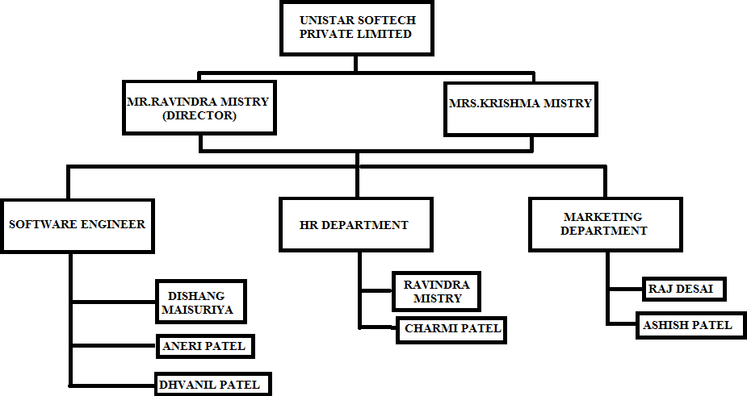

**[Table 1.3: -** ORGANIZATION CHART**]**

# OVERVIEW OF DIFFERENT DEPARTMENT OUT IN COMPANY

## IT INCLUDES THE DETAILS ABOUT THE WORK BEING CARRIED OUT IN EACH DEPARTMENT.

* + - HR Department
    - Software Engineer
    - Sales Department

## LIST THE TECHNICAL SPECIFICATIONS OF MAJOR EQUIPMENT USED IN EACH DEPARTMENT.

* + - **HR Department: -**
      * Recruit Candidates
      * Hire the right employees
      * Process payroll
      * Conduct disciplinary action
      * Update policies
      * Maintain employee records
      * Conduct benefit analysis

## Software Engineer

* + - * Business analyst
      * Product owner
      * Project manager
      * Team lead
      * Software architect
      * Scrum master
      * Developers
      * QA team
      * UX/UI designers
      * Testers

## Sales Department

* Listening to customer needs.
* Track trends and monitor competition.
* Work and transmit brand values.
* Coordinate efforts with those of the marketing partners of the company.
* Innovate.
* Communicate with the rest of the company.
* Help improve sales processes and customer.
* Manage marketing budgets.

## PREPARE SCHEMATIC LAYOUT WHICH SHOWS THE SEQUENCE OF OPERATION FOR MANUFACTURING OF END PRODUCT.

* + 1. **HR Department:**

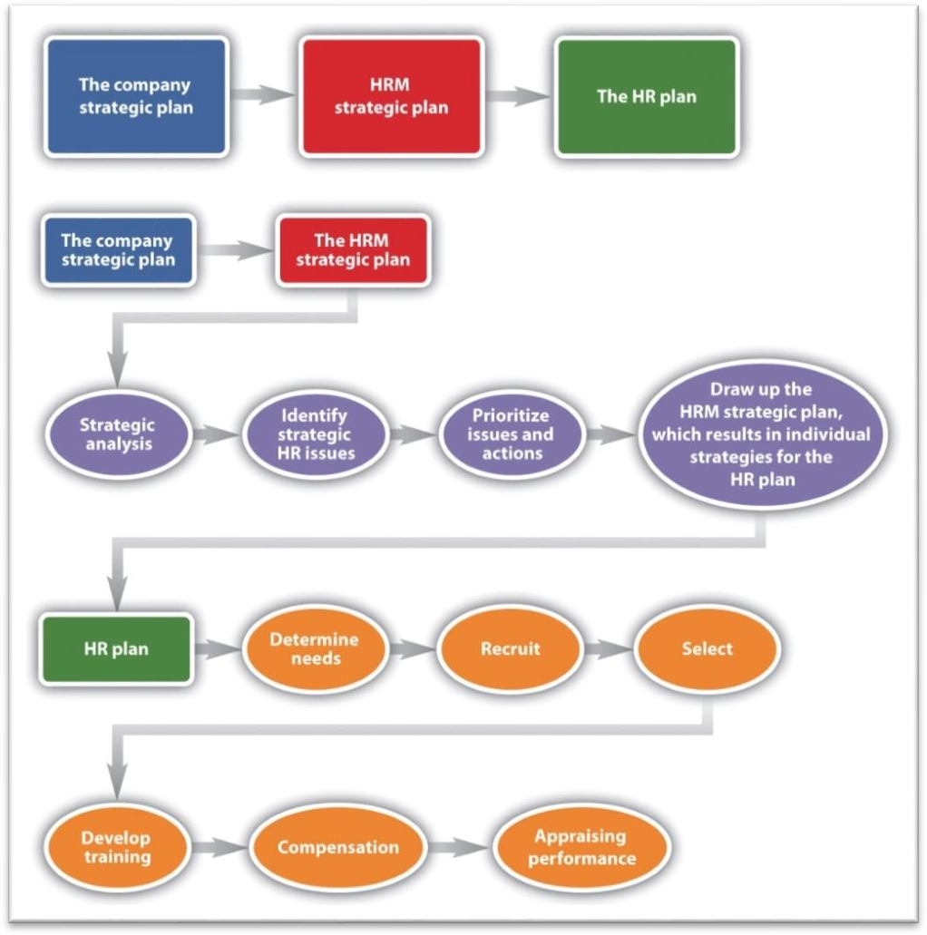

## [Figure2.3.1 : HR Department]

* + 1. **Software Engineer**

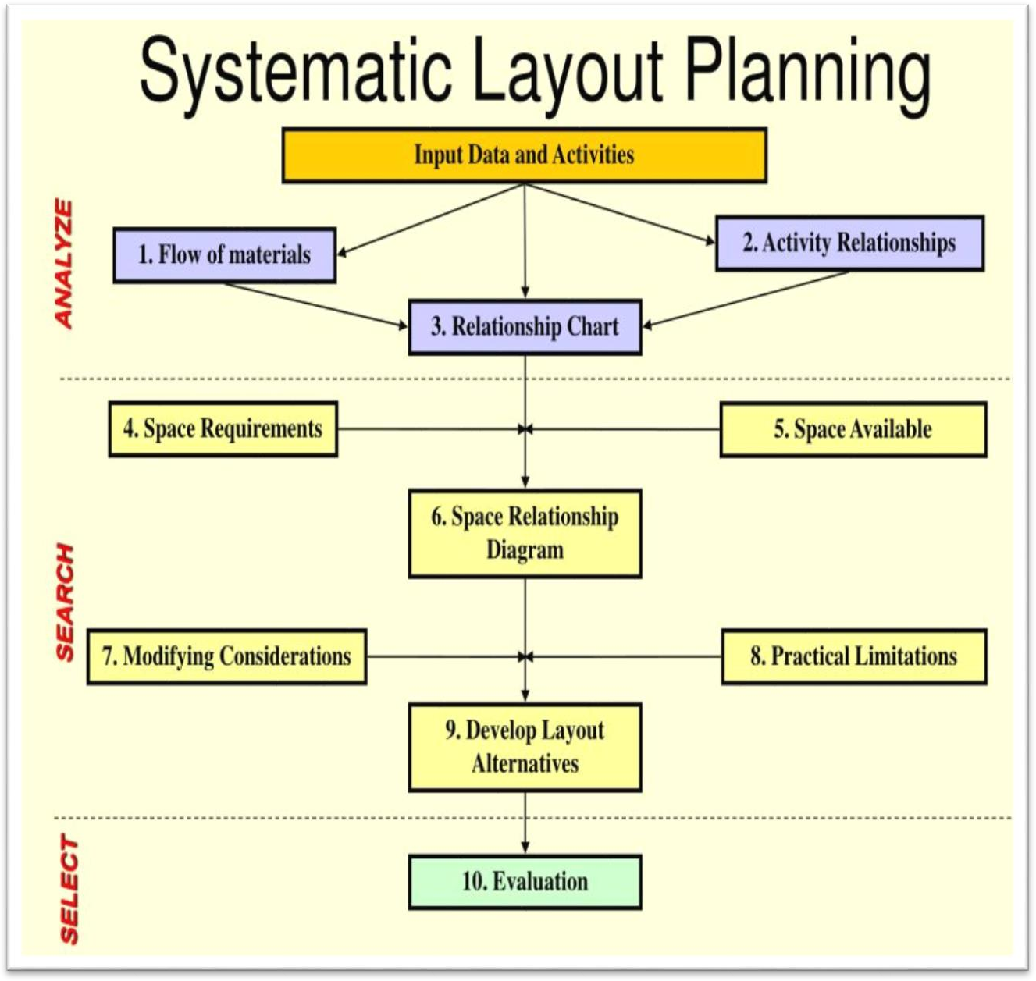

## [Figure 2.3.2: Software Engineer]

* + 1. **Sales Department**

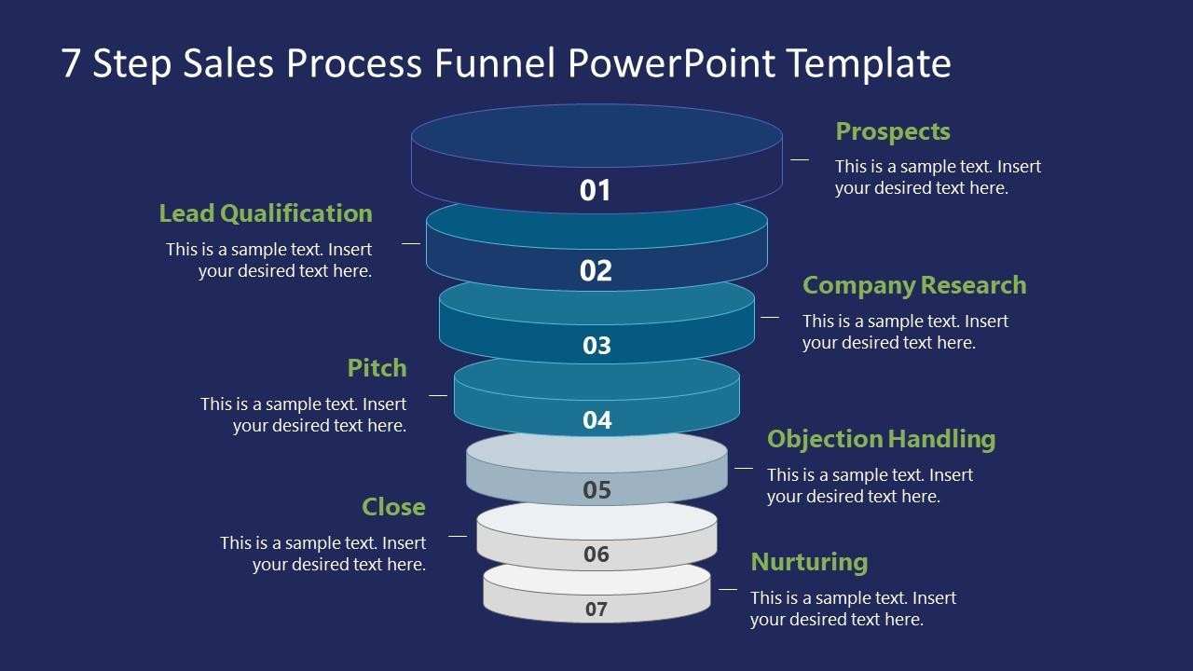

## [Figure 2.3.3 Sales Department]

* 1. **EXPLAIN IN DETAILS ABOUT EACH STAGE OF PRODUCTION.**

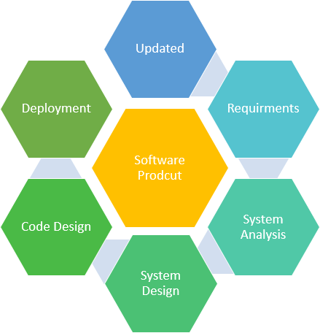

* **Large software** – In our real life, it is quite more comfortable to build a wall than a house or building. In the same manner, as the size of the software becomes large, software engineering helps you to build software.
* **Scalability-** If the software development process were based on scientific and engineering concepts, it is easier to re-create new software to scale an existing one.
* **Adaptability**: Whenever the software process was based on scientific and engineering, it is easy to re-create new software with the help of software engineering.
* **Cost-** Hardware industry has shown its skills and huge manufacturing has lower the cost of the computer and electronic hardware.
* **Dynamic Nature**– Always growing and adapting nature of the software. It depends on the environment in which the user works.
* **Quality Management**: Offers better method of software development to provide quality software products.

**Characteristics of Good Software**

Any software should be judged by what it offers and what are the methods which help you to use it.

Every software must satisfy the following attributes:

* + Operational
  + Transitional
  + Maintenance

Here are some important characteristics of good software developed by software professionals

**Operational**

This characteristic let us know about how well software works in the operations which can be measured on:

* + Budget
  + Efficiency
  + Usability
  + Dependability
  + Correctness
  + Functionality
  + Safety
  + Security

**Transitional**

This is an essential aspect when the software is moved from one platform to another:

* + Interoperability
  + Reusability
  + Portability
  + Adaptability

**Maintenance**

This aspect talks about how well software has the capabilities to adapt itself in the quickly changing environment:

* + Flexibility
  + Maintainability
  + Modularity
  + Scalability

# INTRODUCTION TO PROJECT / INTERNSHIP AND PROJECT

**/ INTERNSHIP MANAGEMENT**

## PROJECT / INTERNSHIP SUMMARY – KEY TO A GOOD SUMMARY IS THE FIRST SENTENCE, WHICH MUST CONTAIN THE MOST ESSENTIAL INFORMATION THAT YOU WISH TO CONVEY.

* + - Summary of project customer can order online cake and view various product and view bill.

## PURPOSE

* + - The Main Purpose of Cake Management to customer easily view cake & Order.
    - Customer Can Give theCake Name and then Customer Give the Order.

## OBJECTIVE

* **General Objective**
  + To increase efficiency and improve services provided to the users through better application of technology indaily operations.
  + The project aims and objective that will be achieved after completion of this project are discussed in this subchapter.

## Specific Objective

* + Category Master
  + Category Wise Entry
  + Customer Registration
  + View Category Wise Entry Detail
  + View Customer
  + Customer Order Detail
  + Customer Cake with Name Order Detail
  + Change Password

## SCOPE (WHAT IT CAN DO AND CAN’T DO)

* + - Admin can Add Category wise cake.
    - Admin Approval for Cake Order.
    - Customer can see the CategoryWise Cake view.
    - Customer Can Give Order.
    - Customer Can Give the Cake Name and then Customer Give the Order.
    - Customer can View Bill.

## TECHNOLOGY AND LITERATURE REVIEW

### TECHNOLOGY

|  |  |
| --- | --- |
| Front-End | PHP CODEIGNITER |
| Back-End | MY SQL |
| Scripting Language | JavaScript (Js) |
| Other Technology | HTML XAMP server |
| Browser | Google Chrome |

* + 1. **LITERATURE REVIEW**

**AUTHOR:** [Katharina Ehrnsperger](https://www.essays.se/about/Katharina%2BEhrnsperger/); [Johanna Pihlgren](https://www.essays.se/about/Johanna%2BPihlgren/) **KEYWORDS:** [bakery industry](https://www.essays.se/about/bakery%2Bindustry/); [marketing](https://www.essays.se/about/marketing/); **ABSTRACT:**

Food trends are evolving in many ways and one of the biggest upcoming trends is the free-from diet, which represents products free from allergen ingredients such as gluten, lactose, etc. The trend has reached individuals with food intolerances as well as people with a health conscious mind who believe this being a healthier way of living. In general, the amount of individuals who are starting to be aware of the free-from term and concept is constantly increasing. The purpose of this master thesis is to evaluate the current adaptation of allergen free products among Swedish bakeries and patisseries

from a marketing perspective. The identified problem in the field is the lack of information concerning how bakeries and patisseries are marketing the allergen free products. The literature review presents different food trends and definitions based on current literature as a conceptual basis for the analysis. In order to answer the research question, a quantitative method in form of a survey was used. There were 38 companies who participated in the survey and the results show that the majority does not market the allergen free products in a different way compared to regular products and that competition within this market is experienced to be rather low. In the analysis, the results are divided into companies with and without allergen free products. This

Master‟s Thesis concludes that bakeries and patisseries in Sweden have successfully introduced allergen free products to the market, but they need to set a deeper focus on the free-from marketing of such products in order to survive future competition.

Moreover, marketing implications are formulated for the Swedish bakery Swebake AB, which is the cooperation company for this thesis. In the last part of this thesis, fields of further research are named.

* 1. **PROJECT / INTERNSHIP SCHEDULING (GANTT CHART/PERT/ NETWORK CHART)**

|  |  |  |  |  |  |  |  |  |  |
| --- | --- | --- | --- | --- | --- | --- | --- | --- | --- |
| **Tasks** | **10-jan-2022 To 30-Apr-2022** | | | | | | | | |
| 1-2 | 2-3 | 3 | 4-6 | 5-10 | 11-12 | 12 | 13-14 | 15 |
| **1.Introduction** |  |  |  |  |  |  |  |  |  |
| Requirement Gathering |  |  |  |  |  |  |  |  |  |
| Analyze Gathered information |  |  |  |  |  |  |  |  |  |
| Determine Basic functionality |  |  |  |  |  |  |  |  |  |
| Determine Scope of System |  |  |  |  |  |  |  |  |  |
| Milestone Completed |  |  |  |  |  |  |  |  |  |
| **2.Planning and Risk analysis** |  |  |  |  |  |  |  |  |  |
| Analyze data for possible risk |  |  |  | |  |  |  |  |  |
| Identify potential risk |  |  |  |  |  |  |  |  |  |
| Determines different modules |  |  |  |  |  |  |  |  |  |
| Milestone Completed |  |  |  |  |  |  |  |  |  |

|  |  |  |  |  |  |  |  |  |  |  |  |
| --- | --- | --- | --- | --- | --- | --- | --- | --- | --- | --- | --- |
| 161230107040 OVERVIEWS OF THE INTERNSHIP | | | | | | | | | | | |
|  | **3.Designing** |  |  |  |  |  |  |  |  |  |  | |  |
| Design basic interface |  |  |  | |  |  |  |  |  |  | |  |
| Design database table |  |  |  |  | |  |  |  |  |  | |  |
| Design UI model |  |  |  |  |  |  |  |  |  |  | |  |
| Milestone Completed |  |  |  |  |  |  |  |  |  |  | |  |
| **4.Coding and integrated modules** |  |  |  |  |  |  |  |  |  |  | |  |
| Define code logics |  |  |  |  | | | | |  |  | |  |
| Implementation of logics |  |  |  |  |  | |  |
| Master modules |  |  |  |  |  | |  |  |  |  | |  |
| Transaction modules |  |  |  |  |  | | |  |  |  | |  |
| Milestone Completed |  |  |  |  |  |  |  |  |  | |
| **5.Testing** |  |  |  |  |  |  |  |  |  | |
| Validate input data on control |  |  |  |  |  |  |  | |  | |
| Check accuracy of transaction |  |  |  |  |  |  |  |  |  | |
| Test system with multiple users |  |  |  |  |  |  |  |  | |
| Milestone Completed |  |  |  |  |  |  |  |  |  | |
| GUJARAT TECHNOLOGICAL UNIVERSITY 12 S.S.A.I.E.T. NAVSARI | | | | | | | | | | | |

# SYSTEM ANALYSIS

## STUDY OF CURRENT SYSTEM

* + - Presently the system is completely manual. All the entries of Product Booking are maintained manually. There is lot of paper work, maintain details Customer,Admin which is very tedious & crude method. So, understandably to maintain the records of Product booking manually is very difficult.
    - Various reports are also on paper work. A lot of time is required for filling theProduct booking and maintains the record of Customer booking.
    - There is a need to replace the existing system by a system which will reduce thejob to a few clicks & which will help him to maintain the important records accurately and safer. System should also help for faster retrieval of data and show the result instantly.

## PROBLEM AND WEAKNESSES OF CURRENT SYSTEM

* **Manpower**: -

Man power is needed for processes like maintenances of register customers, records of bookings.

* **Time Consuming: -**

The existing system is very time consuming as customer requires to search for another site for another booking purpose, that increases customers searching time.

* **Storing & Retrieving: -**

storing & retrieving process is very slow and also it requires a separate storage area.

* **Hectic Job: -**

It is very hectic job to search in previous records.

## REQUIREMENTS OF NEW SYSTEM

* The proposed system is internet-based system so employee, customer and Admin can also participate in this system.
* They provide domain login as per cake requirement so need to remember user id and password.
* The main objective of the system is its simplicity of design and implementation that shows and helps to collect most of the information about cake order services.
* The main purpose to develop this system is to provide online cake order to the customer.
* Customer can order his/her name into the cake design.

## ACTIVITY / PROCESS IN NEW SYSTEM / PROPOSED SYSTEM

Cake management is web application to manage admin & Customer management. This system provides online services to order cake and also to the customer. In this service is view cake menu and name with cake by the customer through the system online, customer detail manage by the admin. Customer can pay the bill with cash. Customer can check the daily view cake details.

The main purpose to develop this system is to provide cake with name service online to the customer. Online order is one of the important facilities provided in cake and bake to pay the bill for cake order.

Admin manage customer data like Add, Update, Delete, View and Search customer. Admin manage View customer Order, payment.

Customer can view order details online.

## FEATURES OF NEW SYSTEM / PROPOSED SYSTEM

* Customer can pay the bill amount by cash.
* Customer can Cake order & cake with name order online.
* Provide Computerized System for maintaining records.
* More efficient & reliable.
* Less time consuming and easy to use.
* Avoid Human errors & efforts for maintaining daily data.

## LIST MAIN MODULES / COMPONENTS / PROCESSES / TECHNIQUES OF NEW SYSTEM / PROPOSED SYSTEM

Generally, our system consists of mainly the below listed modules: -

1. Admin
2. Customer

## SELECTION OF HARDWARE / SOFTWARE / ALGORITHMS / METHODOLOGY / TECHNIQUES / APPROACHES AND JUSTIFICATION

|  |  |
| --- | --- |
| **Web Requirement** | Band width – 10 mbps (Minimum). |
| **Development Environment** | Processor - Intel(R) Core™ 2 Duo Processor  RAM – 1 GB HDD – 100 GB  Operating System – Windows 7 & Above |
| **Client Configuration** | Internet – 512 Kbps (Minimum).  Internet Explorer 6.0 and above. |

* **Technologies Used**

|  |  |
| --- | --- |
| **Front-End** | PHP |
| **Back-End** | MYSQL |
| **Scripting Language** | JavaScript (Js) |

# SYSTEM DESIGN

## SYSTEM DESIGN & METHODOLOGY

### Use Case Diagram

* + - * **Admin side**

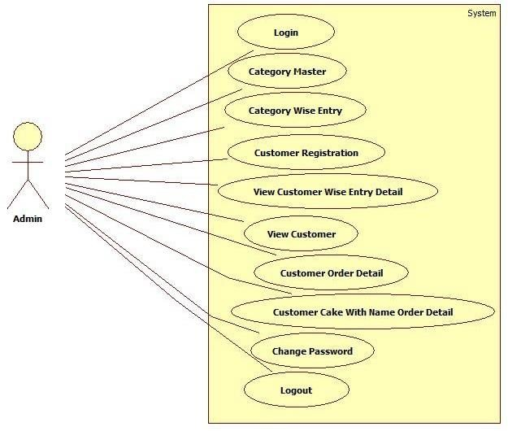

**[Figure 5.1.1:** Use Case Diagram (admin side)**]**

### Customer side

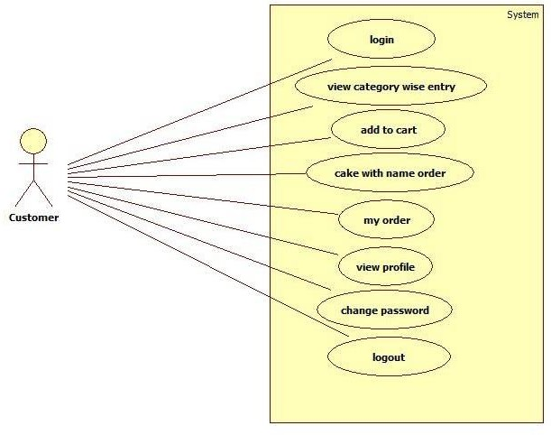

**[Figure 5.1.2:** Use Case Diagram (Customer side)**]**

## Class Diagram

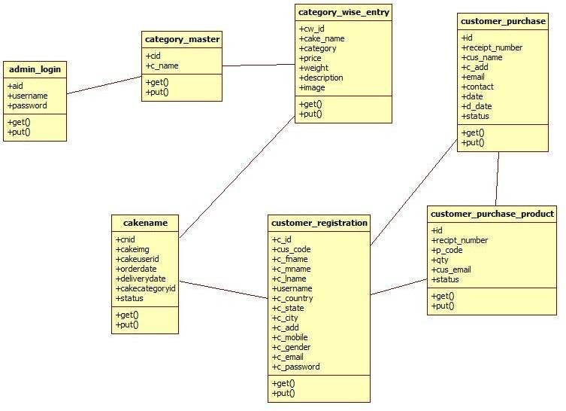

* + **Activity Diagram:**
* Login Activity Diagram

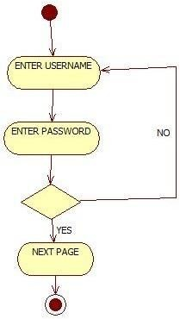

\

* Category Master Activity Diagram

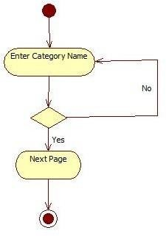

* Menu Activity Diagram

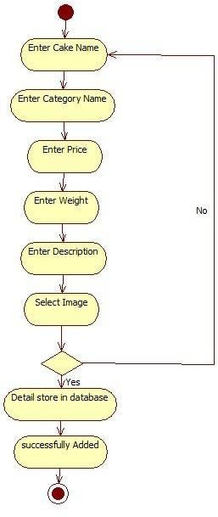

* Customer Registration Activity Diagram

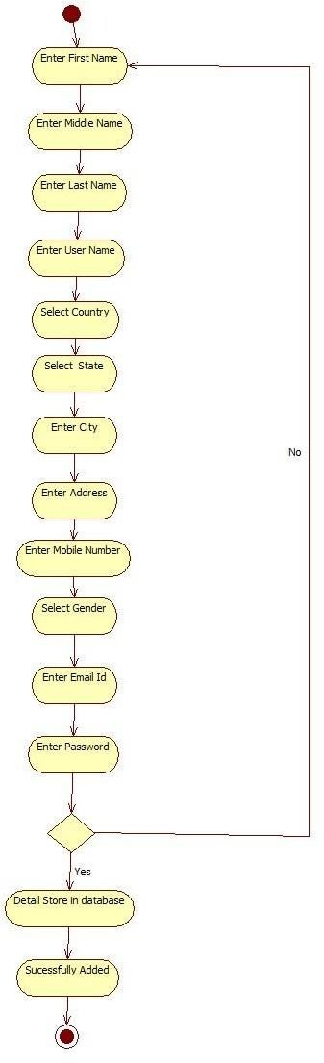

* Change Password Activity Diagram

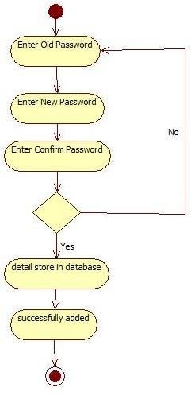

* Customer Cake Order Activity Diagram

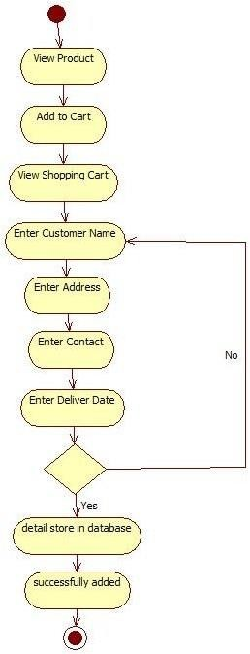

* Customize Order Activity Diagram

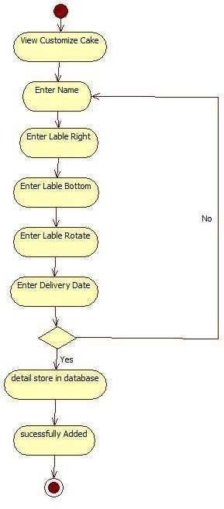

**Sequence Diagram:**

Fig 1: Login Sequence Diagram

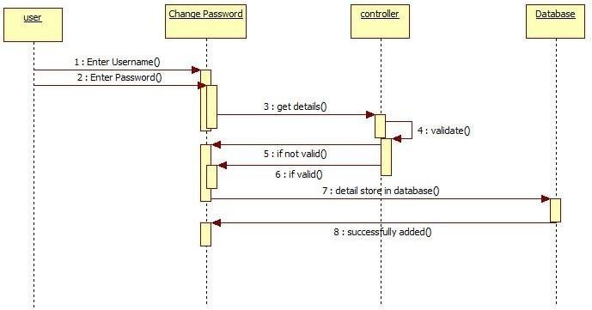

Fig 2: Category master Sequence Diagram

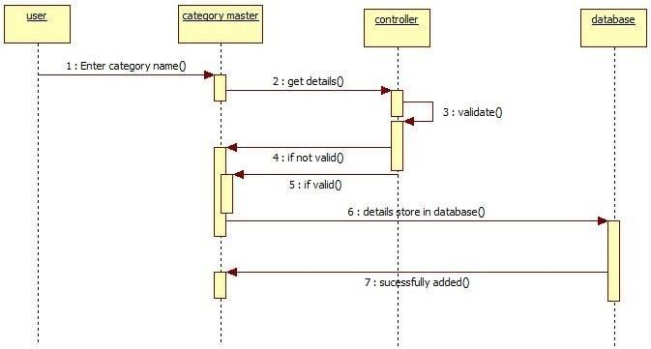

Fig 3: Menu Sequence Diagram

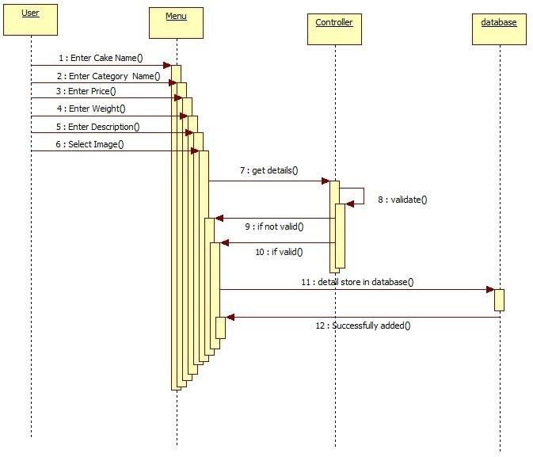

Fig 4:Customer Registration Sequence Diagram

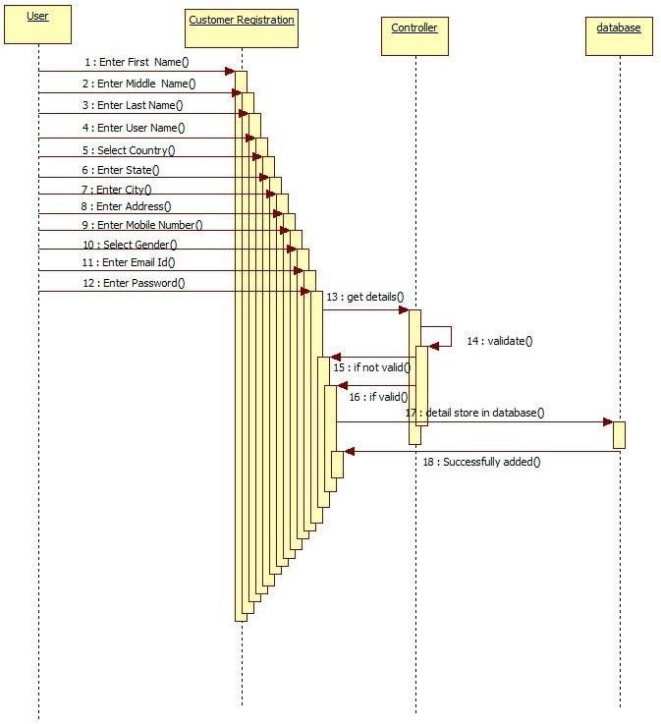

Fig 5:Change Password Sequence Diagram

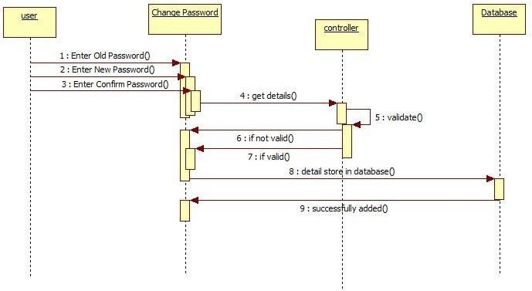

Fig 6:Customer Cake Order Sequence Diagram

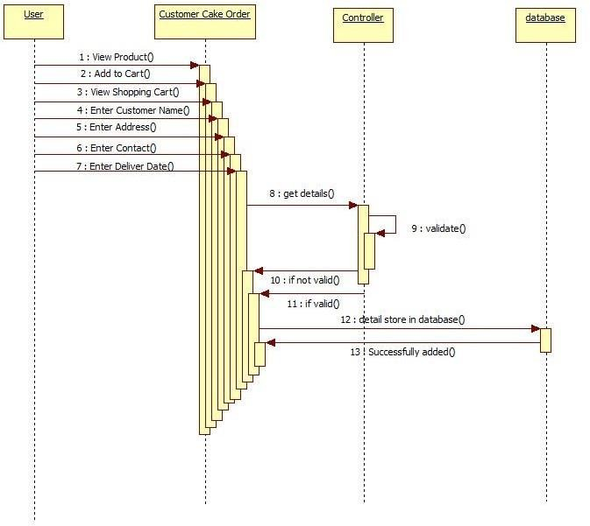

Fig 7:Customize Order Sequence Diagram

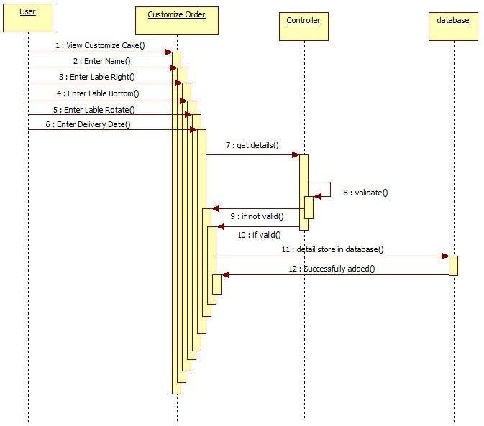

## DATABASE DESIGN / DATA STRUCTURE DESIGN / CIRCUIT DESIGN / PROCESS DESIGN / STRUCTURE DESIGN

**Table 1: admin_login**

|  |  |  |  |
| --- | --- | --- | --- |
| **Attribute Name** | **Data type** | **Constrai nt** | **Description** |
| **aid** | Int(11) | Primar  y Key | Auto increment id |
| **firstname** | Varchar(100  ) | - | Enter First Name |
| **lastname** | Varchar(20) | - | Enter Last Name |
| **email** | Varchar(20) | - | Enter Email Id |
| **username** | Varchar(20) | - | Enter Username |
| **password** | Varchar(20) | - | Enter Password |

Table 2 : cakename

|  |  |  |  |
| --- | --- | --- | --- |
| **Attribute Name** | **Data type** | **Constrai nt** | **Description** |
| **Cnid** | Int(11) | Primar  y Key | Enter cake name id |
| **Cakeimg** | Varchar(100  ) | - | Upload cakeimage |
| **cakeuserid** | Varchar(20) | - | Enter cake user  id |
| **orderdate** | Varchar(20) | - | Enter order date |
| **deliverydate** | Varchar(20) | - | Enter delivery date |
| **cakecategoryid** | Int(11) | Foreig n  Key | Enter cake catgory id |
| **status** | Varchar(20) | - | Enter status |

Table 3: category_master

|  |  |  |  |
| --- | --- | --- | --- |
| **Attribute Name** | **Data type** | **Constrai nt** | **Description** |
| **cid** | Int(11) | Primar  y Key | Auto increment id |
| **c_name** | Varchar(100  ) | - | Enter category  name |

Table 4 : category_wise_entry

|  |  |  |  |
| --- | --- | --- | --- |
| **Attribute Name** | **Data type** | **Constrai nt** | **Description** |
| **cw_id** | Int(11) | Primar  y key | Enter cake wise id |
| **cake_name** | Varchar(35) | - | Enter cake name |
| **category** | Varchar(30) | - | Enter category |
| **Price** | Varchar(20) | - | Enter price |
| **weight** | Varchar(20) | - | Enter weight |
| **description** | Varchar(100  ) | - | Enter description |
| **image** | Varchar(100  ) | - | Upload image |

Table 5 : customer_purchase

|  |  |  |  |
| --- | --- | --- | --- |
| **Attribute Name** | **Data type** | **Constrai nt** | **Description** |
| **Id** | Int(11) | Primar  y key | Enter id |
| **receipt_number** | Varchar(30) | - | Enter  receipt number |
| **cus_name** | Varchar(100  ) | - | Enter customername |
| **c_add** | Varchar(100  ) | - | Enter  customer address |
| **email** | Varchar(50) | - | Enter email |
| **contact** | Varchar(50) | - | Enter contact  number |
| **Date** | Varchar(50) | - | Enter date |
| **d_date** | Varchar(50) | - | Enter delivery date |
| **status** | Varchar(50) | - | Enter status |

Table 6: customer_purchase_product

|  |  |  |  |
| --- | --- | --- | --- |
| **Attribute Name** | **Data type** | **Constrai nt** | **Description** |
| **Id** | Int(11) | Primar yKey | Enter id |
| **receipt_number** | Varchar(30) | - | Enter receipt number |
| **p_code** | Varchar(100  ) | - | Enter product code |
| **Qty** | Varchar(100  ) | - | Enter quantity |
| **cus_email** | Varchar(50) | - | Enter customer email |
| **status** | Varchar(50) | - | Enter status |

|  |  |  |  |  |
| --- | --- | --- | --- | --- |
| 161230107040 SYSTEM DESIGN  Table 7: customer_registration | | | | |
|  | **Attribute Name** | **Data type** | **Constraint** | **Description** |
| **c_id** | Int(11) | Primary  Key | Enter customer id |
| **cust_code** | Varchar(20) | - | Enter customer  code |
| **c_fname** | Varchar(20) | - | Enter customer  first name |
| **c_mname** | Varchar(20) | - | Enter customer middle name |
| **c_lname** | Varchar(20) | - | Enter customer  last name |
| **username** | Varchar(20) | - | Enter customer  user name |
| **c_country** | Varchar(20) | - | Enter customer  country |
| **c_state** | Varchar(20) | - | Enter customer  state |
| **c_city** | Varchar(20) | - | Enter customer  city |
| GUJARAT TECHNOLOGICAL UNIVERSITY 37 S.S.A.I.E.T. NAVSARI | | | | |

|  |  |  |  |  |
| --- | --- | --- | --- | --- |
| 161230107040 SYSTEM DESIGN | | | | |
|  | **c_add** | Varchar(100) | - | Enter customer address |
| **c_mobile** | Varchar(20) | - | Enter customer  mobile number |
| **c_gender** | Varchar(20) | - | Enter customer  gender |
| **c_email** | Varchar(20) | - | Enter customer  email |
| **c_password** | Varchar(20) | - | Enter customer  password |
| GUJARAT TECHNOLOGICAL UNIVERSITY 38 S.S.A.I.E.T. NAVSARI | | | | |

## INPUT / OUTPUT AND INTERFACE DESIGN (IF APPLICABLE) Home Page:

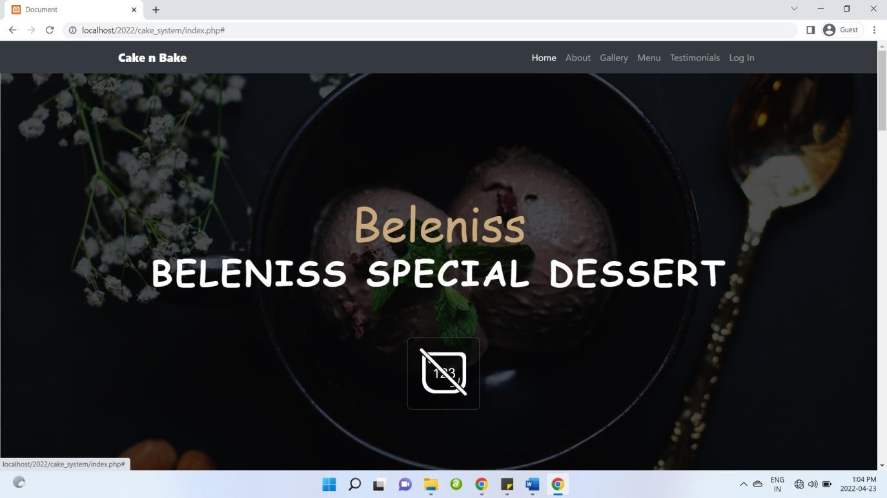

**Customer Registration**

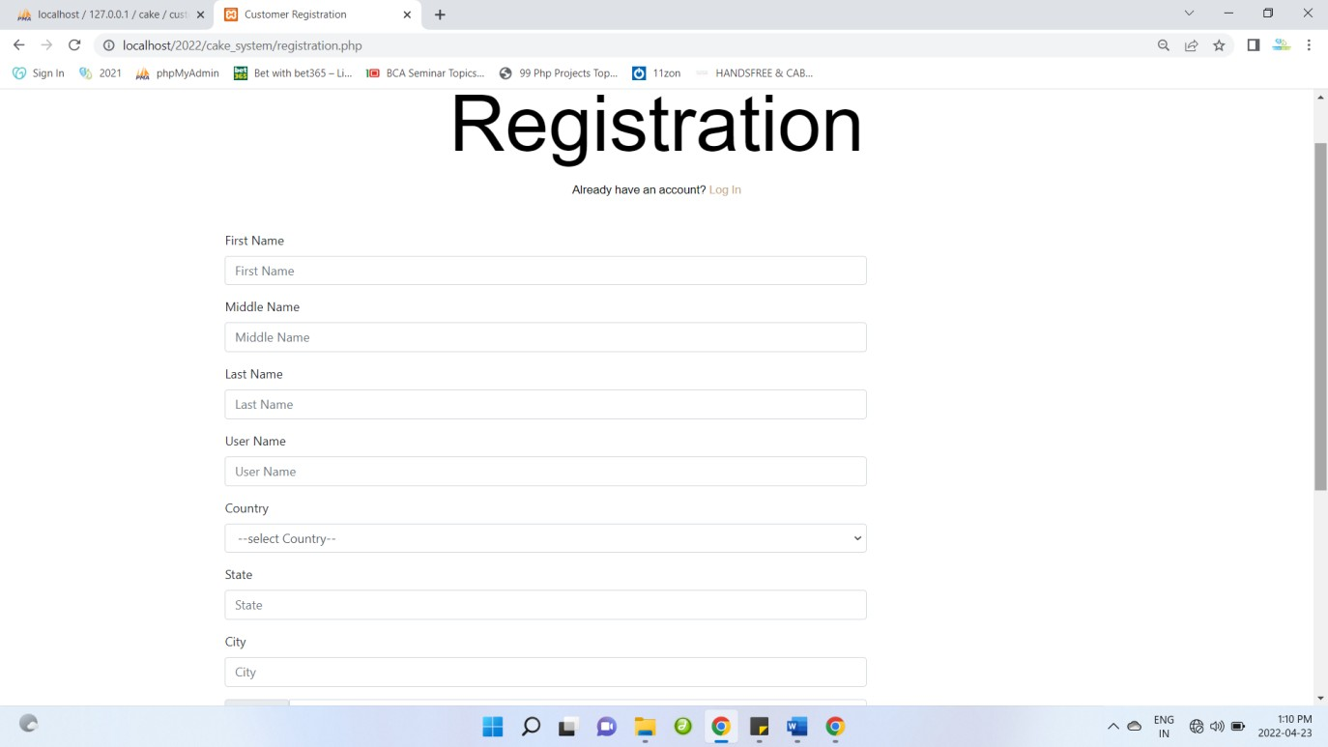

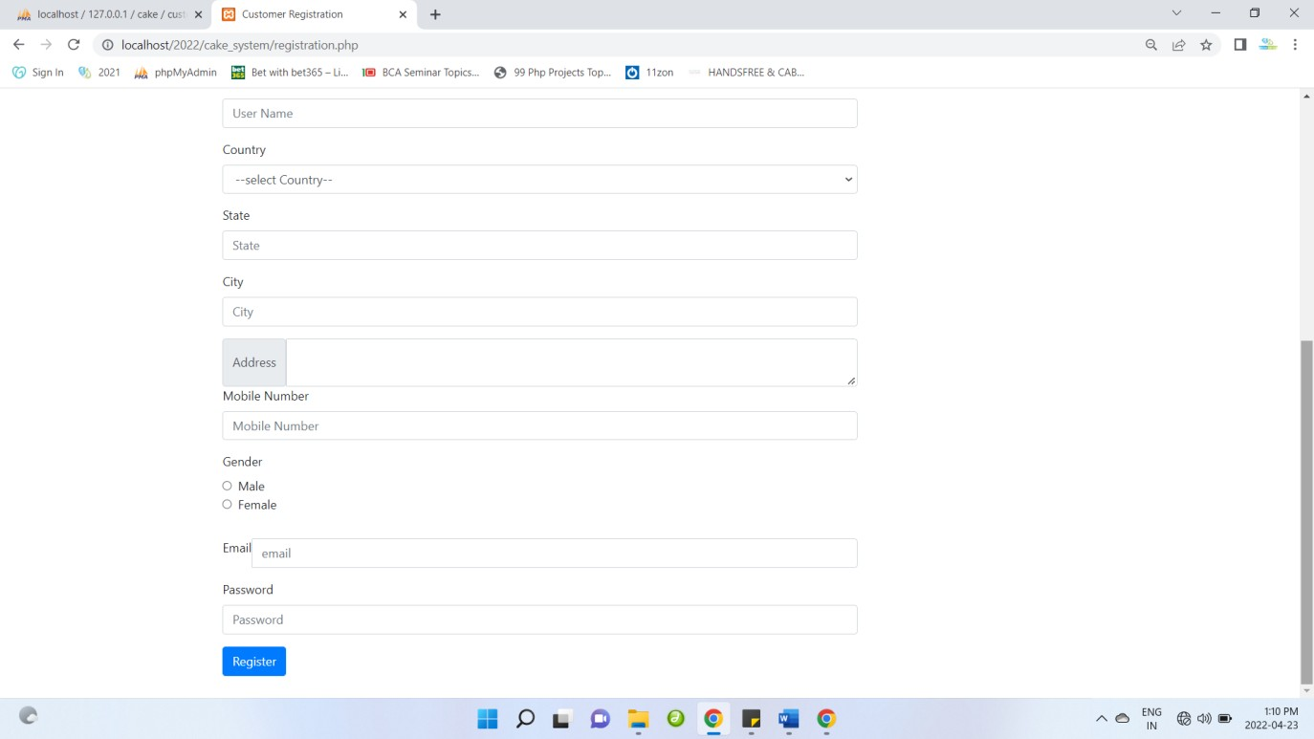

**Admin Login**

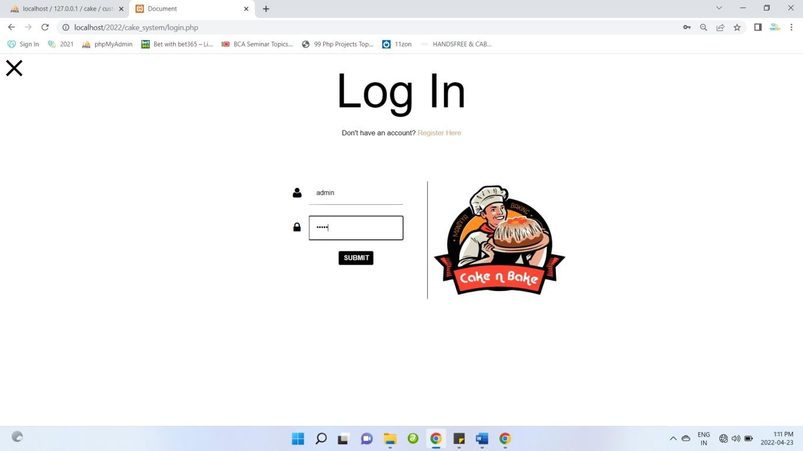

* 1. **IMPLEMENTATIONS**

## MODULES SPECIFICATION(S)

* + 1. **Admin**
       - Login
       - Category Master
       - Category Wise Entry
       - Customer Registration
       - View Category Wise Entry Detail
       - View Customer
       - Customer Order Detail
       - Customer Cake with Name Order Detail
       - Customer Wise Search
       - Order wise Search
       - Date wise search
       - Change Password
       - Logout

## Customer

* + - * Login
      * View Category Wise Cake
      * Add To Cart
      * Cake With Name Order
      * My Order
      * View Profile
      * Change Password
      * Logout

## IMPLEMENTATION & SCREEN LAYOUT Category Master:

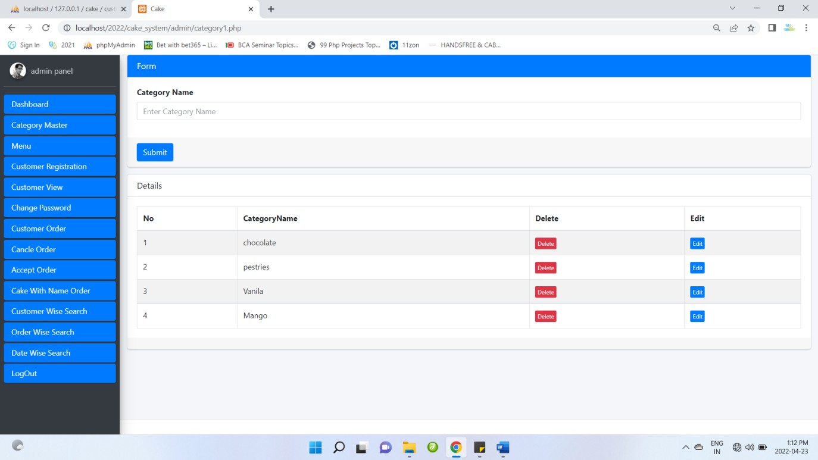

**Category Edit:**

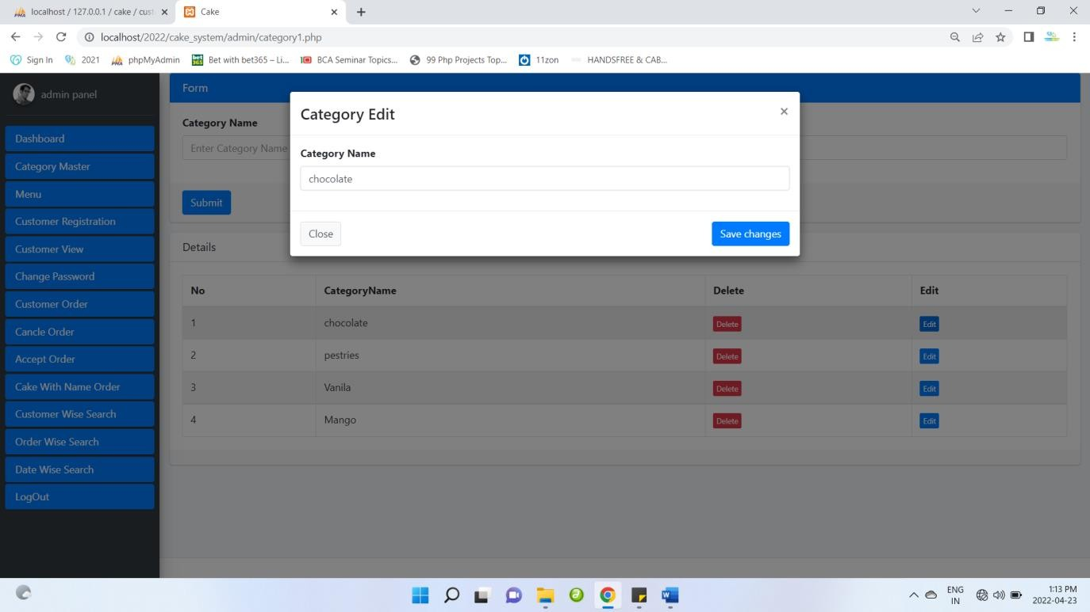

## Category Delete:

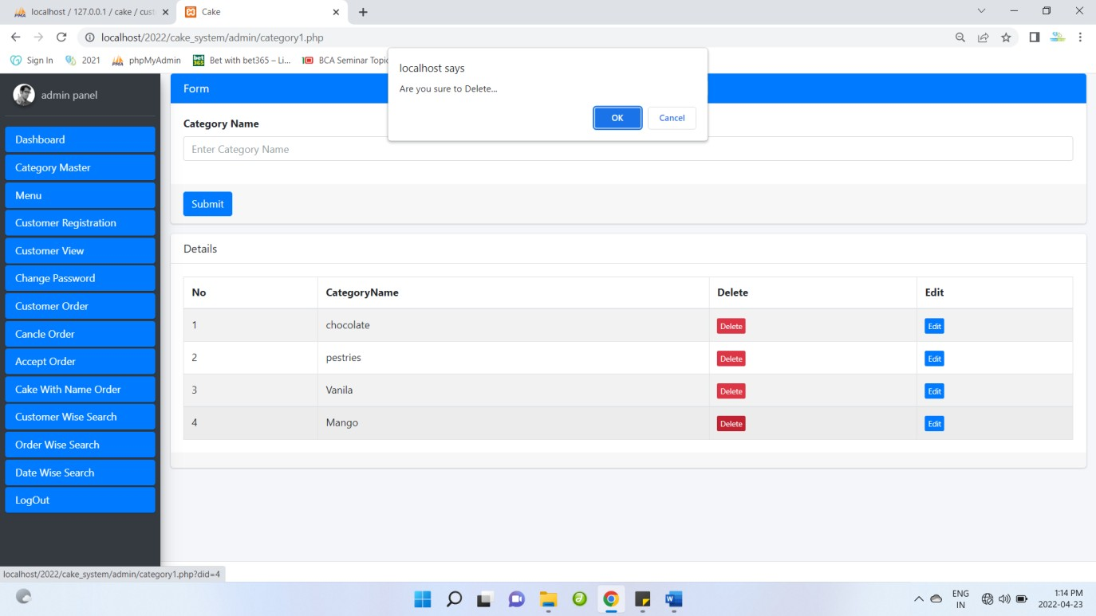

**Menu Master**

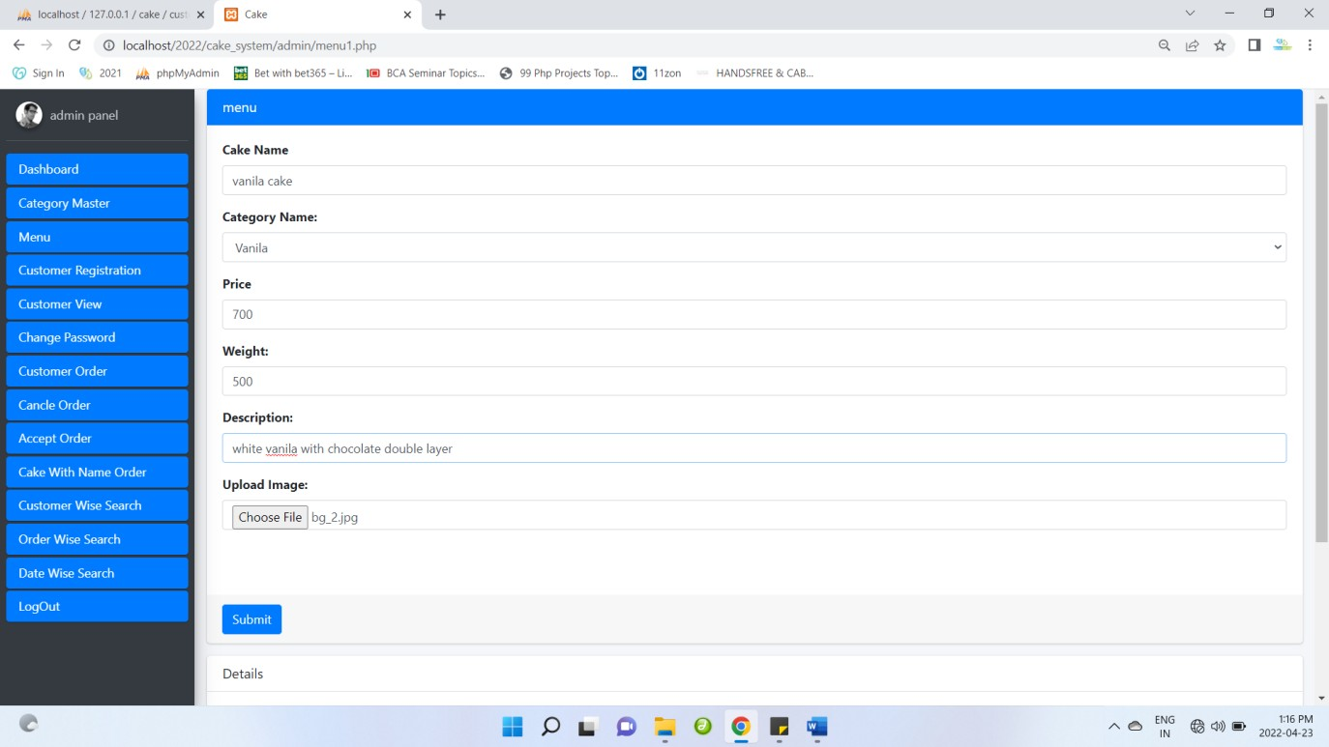

## View Detail

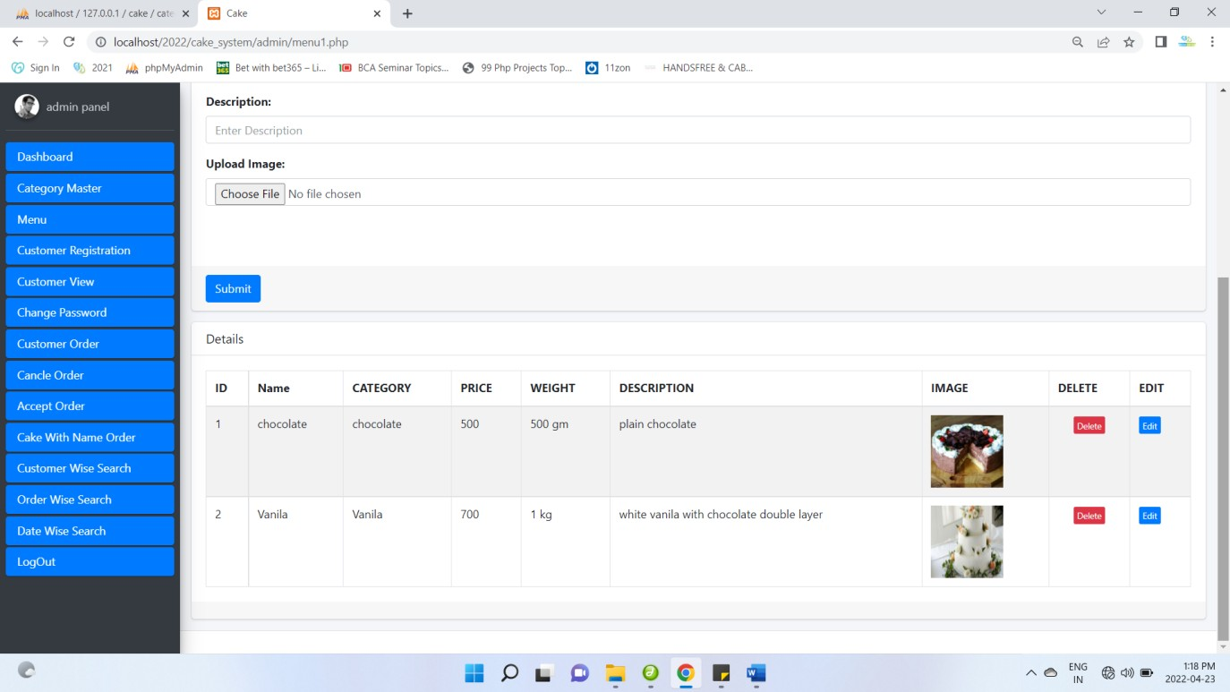

**Edit Detail**

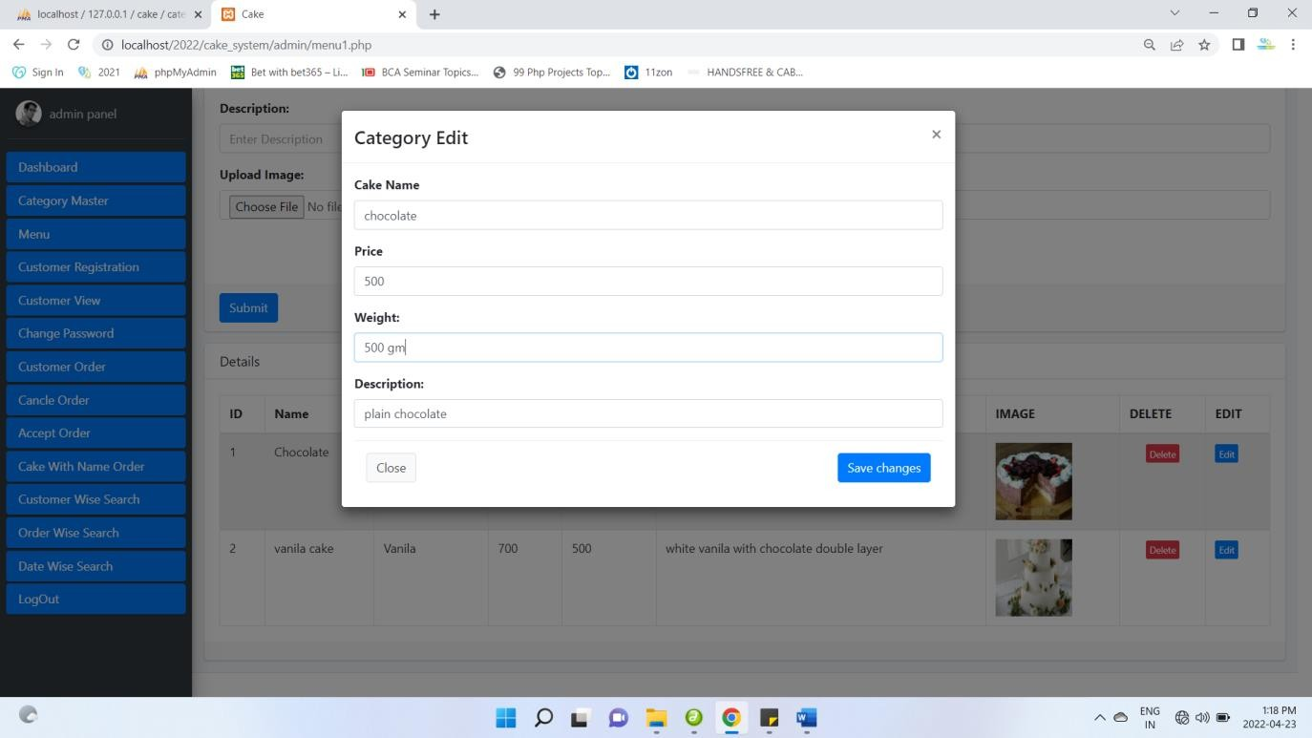

## Delete Menu

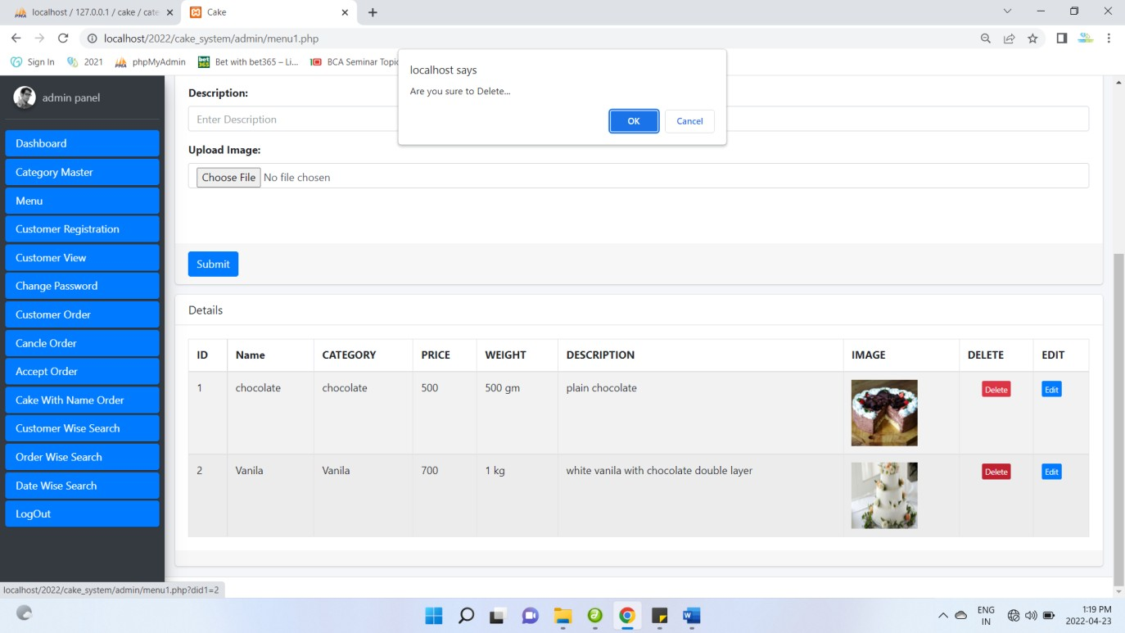

**Customer Detail**

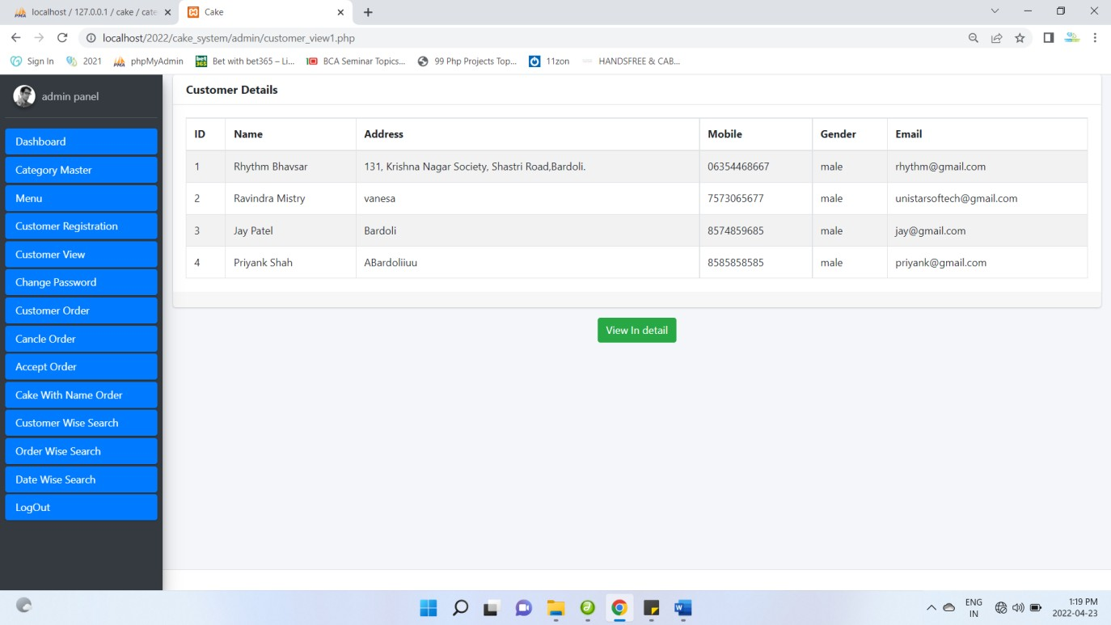

## Change Password

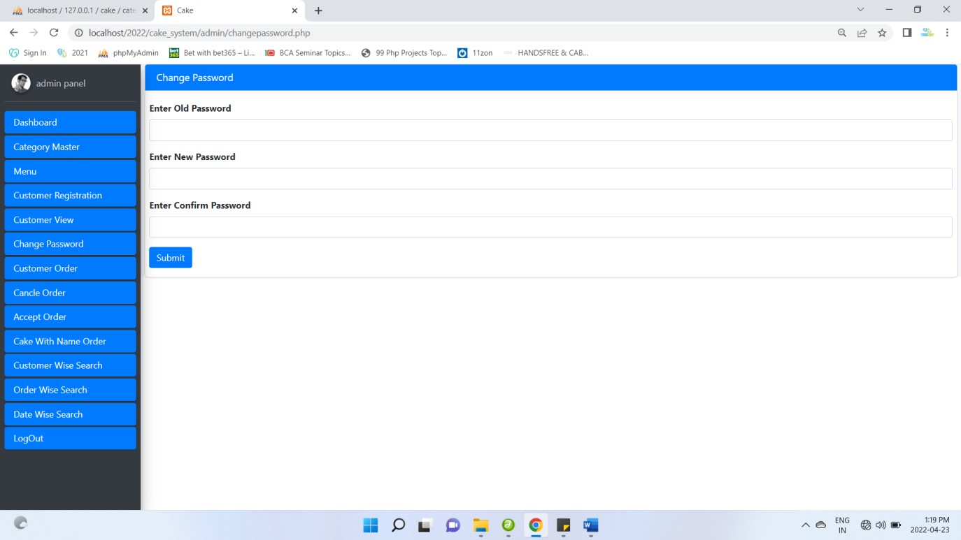

**Customer Login**

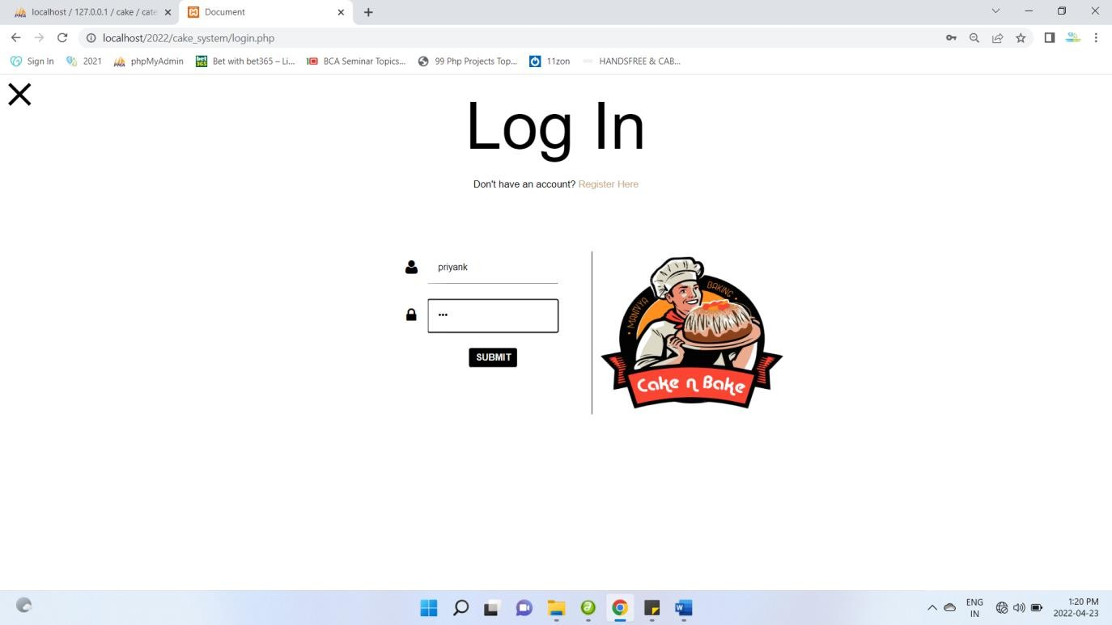

## Customer Home Page:

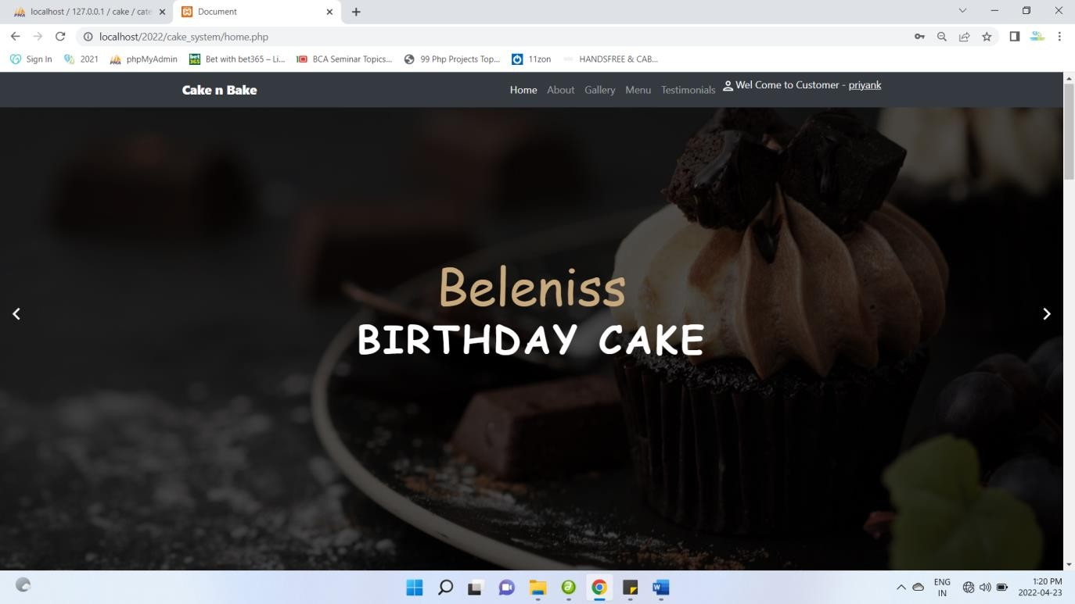

**View profile**

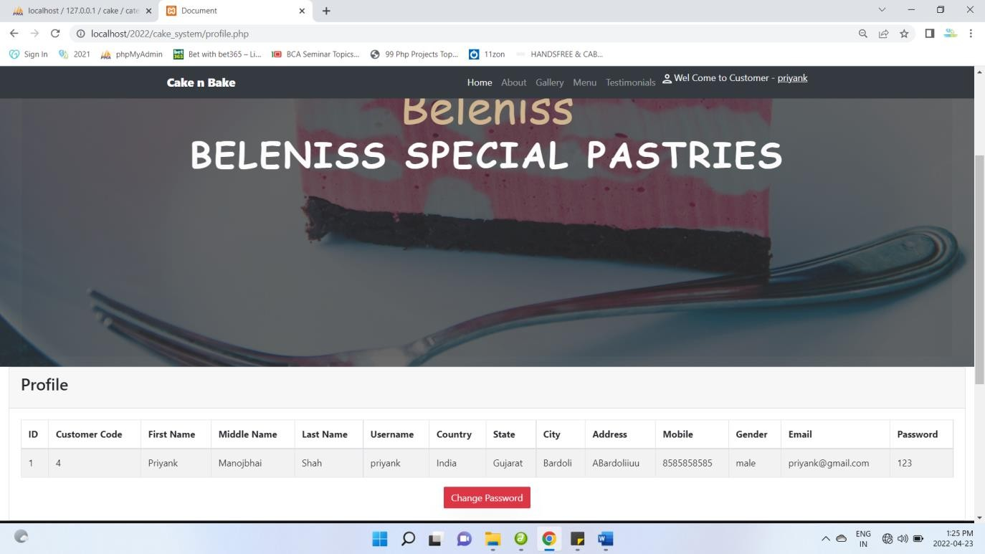

## Change password

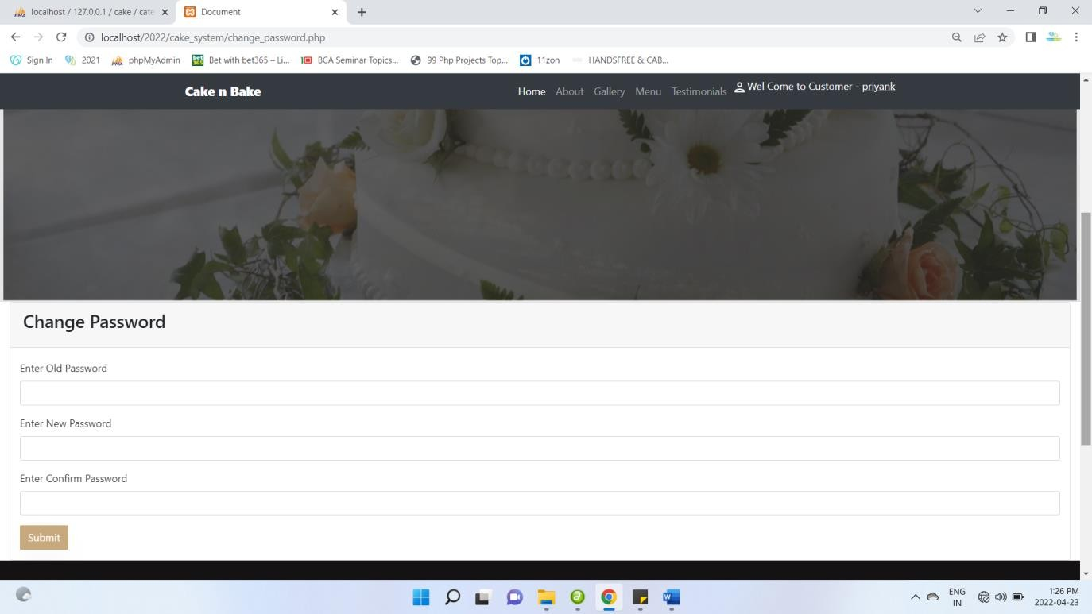

**View Cake**

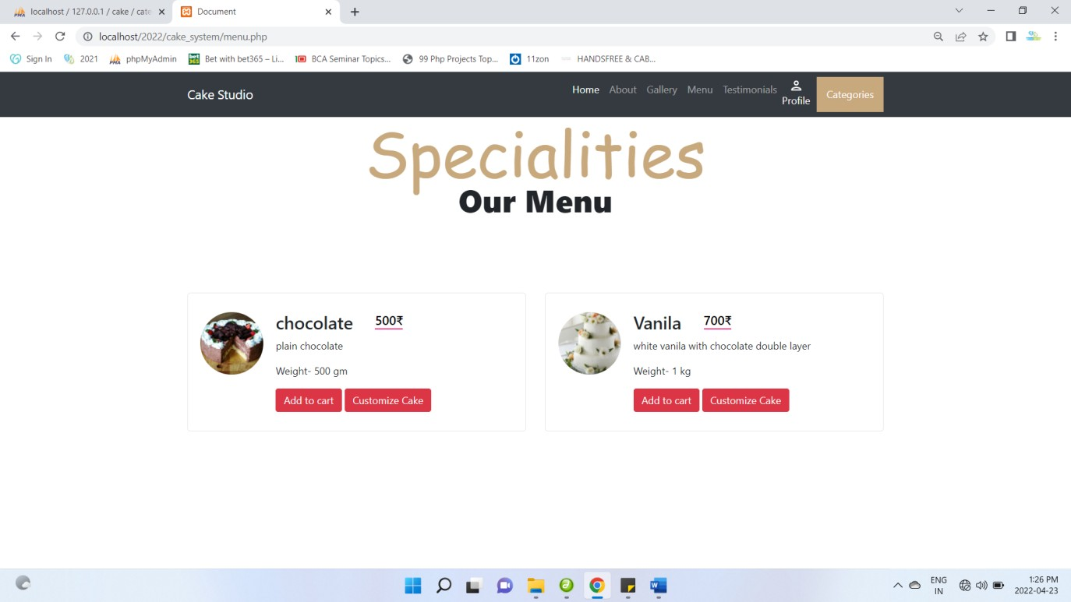

## Add To cart

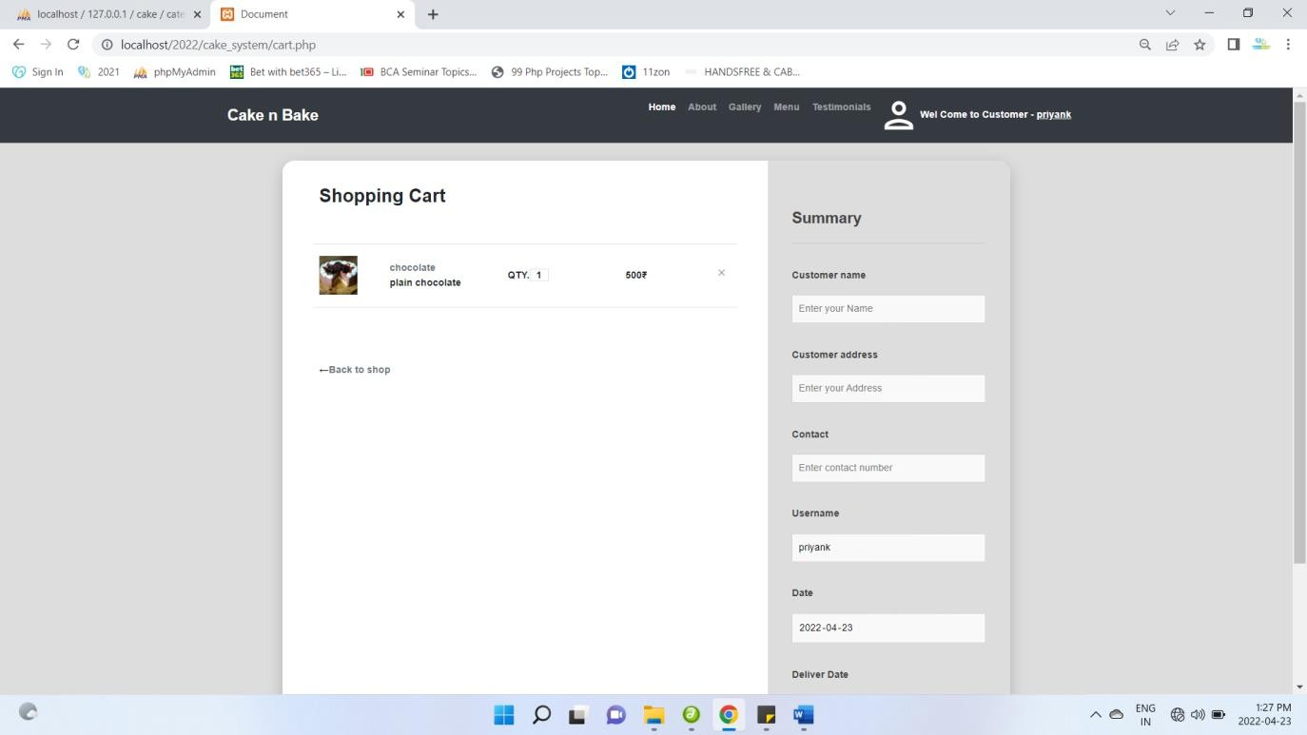

**Add Quantity**

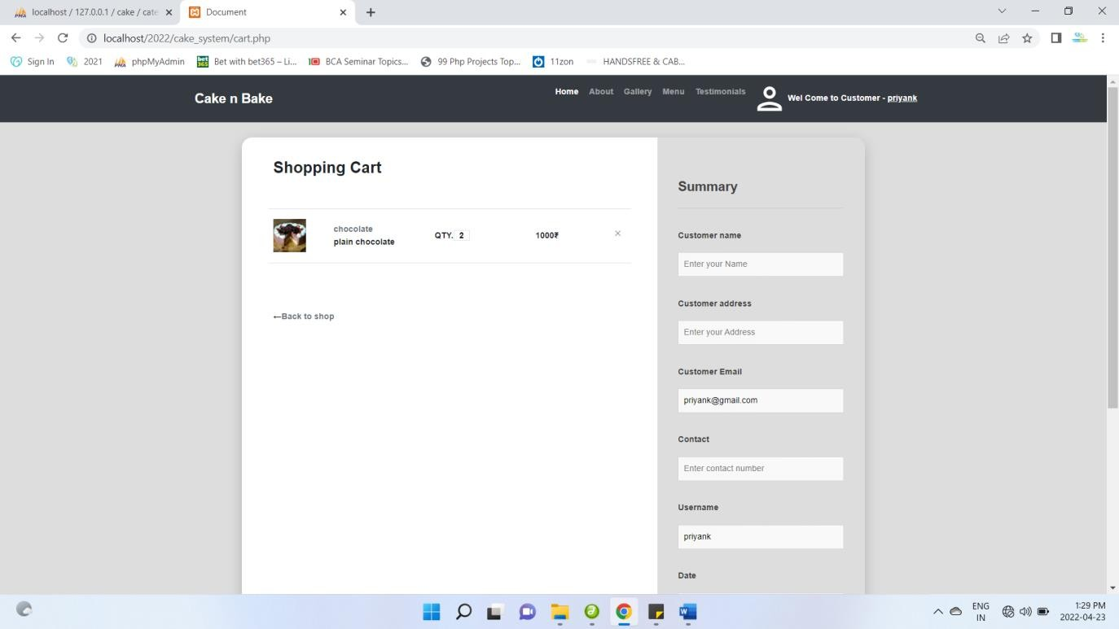

## Date & Time Validate

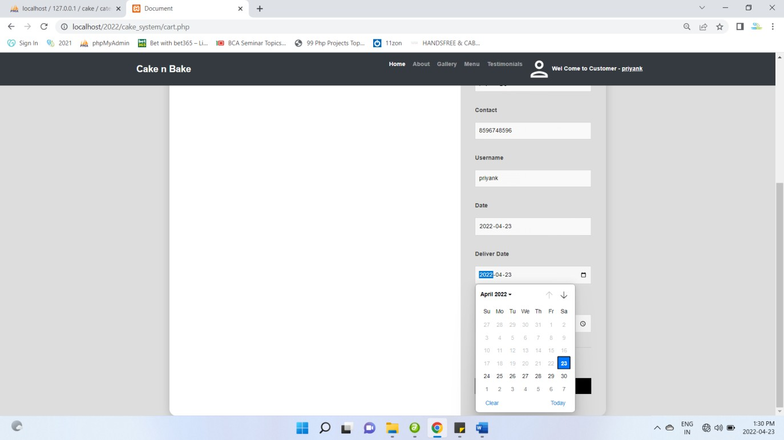

**Place Order**

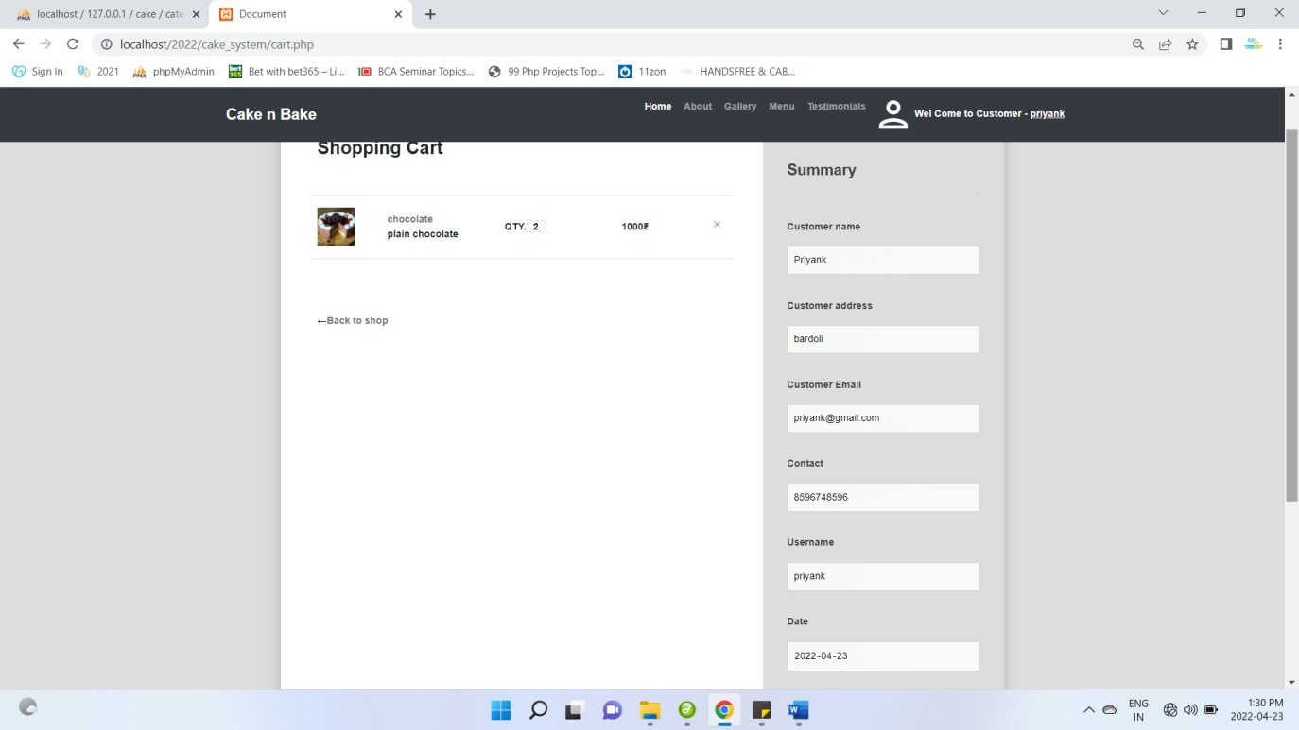

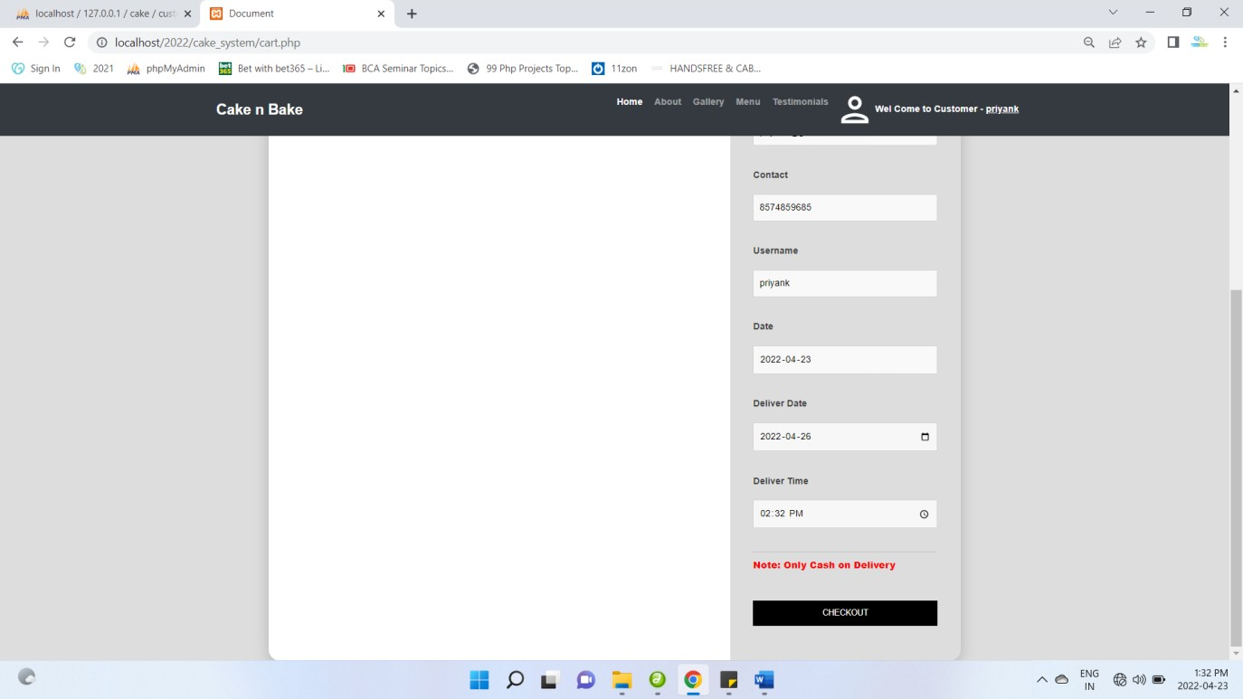

## View Order

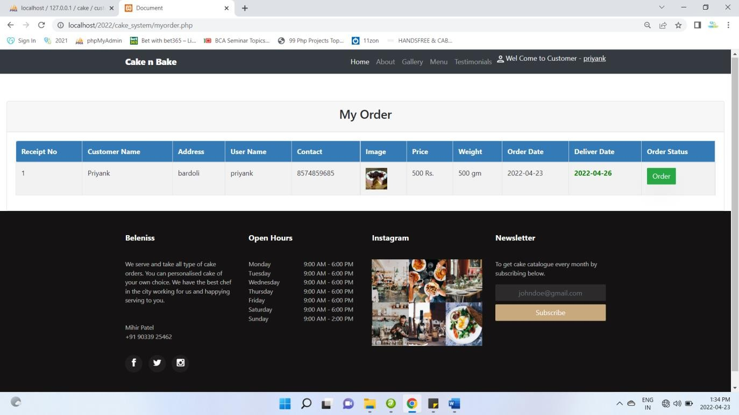

**Admin Panel View Customer order**

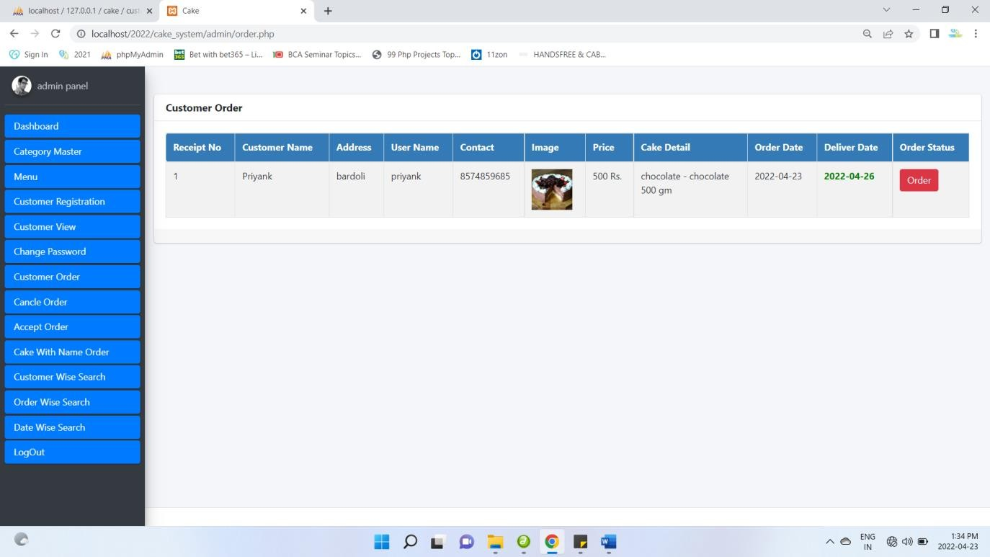

## Customer Order Status

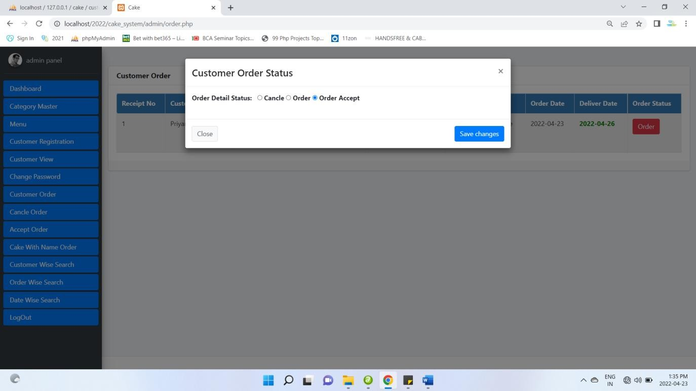

**Customer Order cancel**

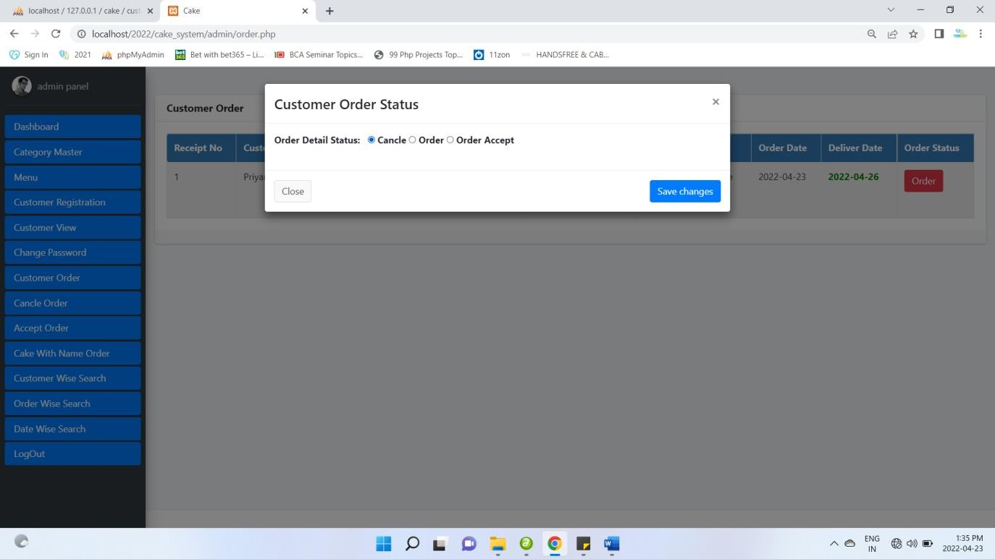

## Accept Order

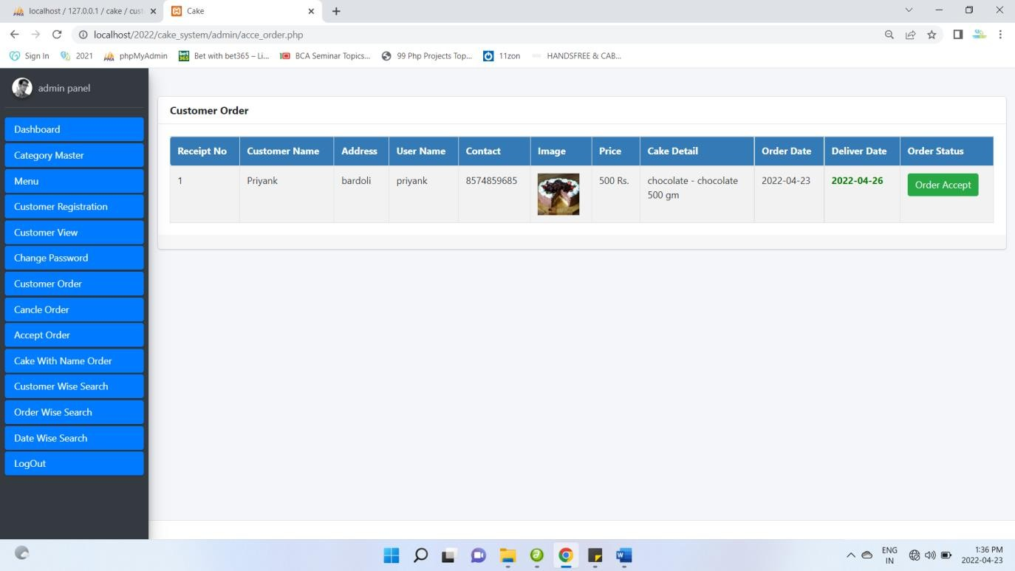

**Customer Panel Order Accept**

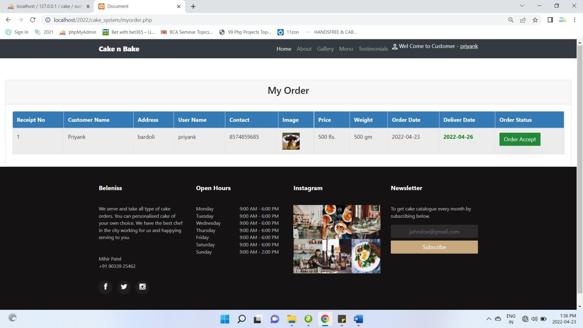

## Customer Customize Cake order

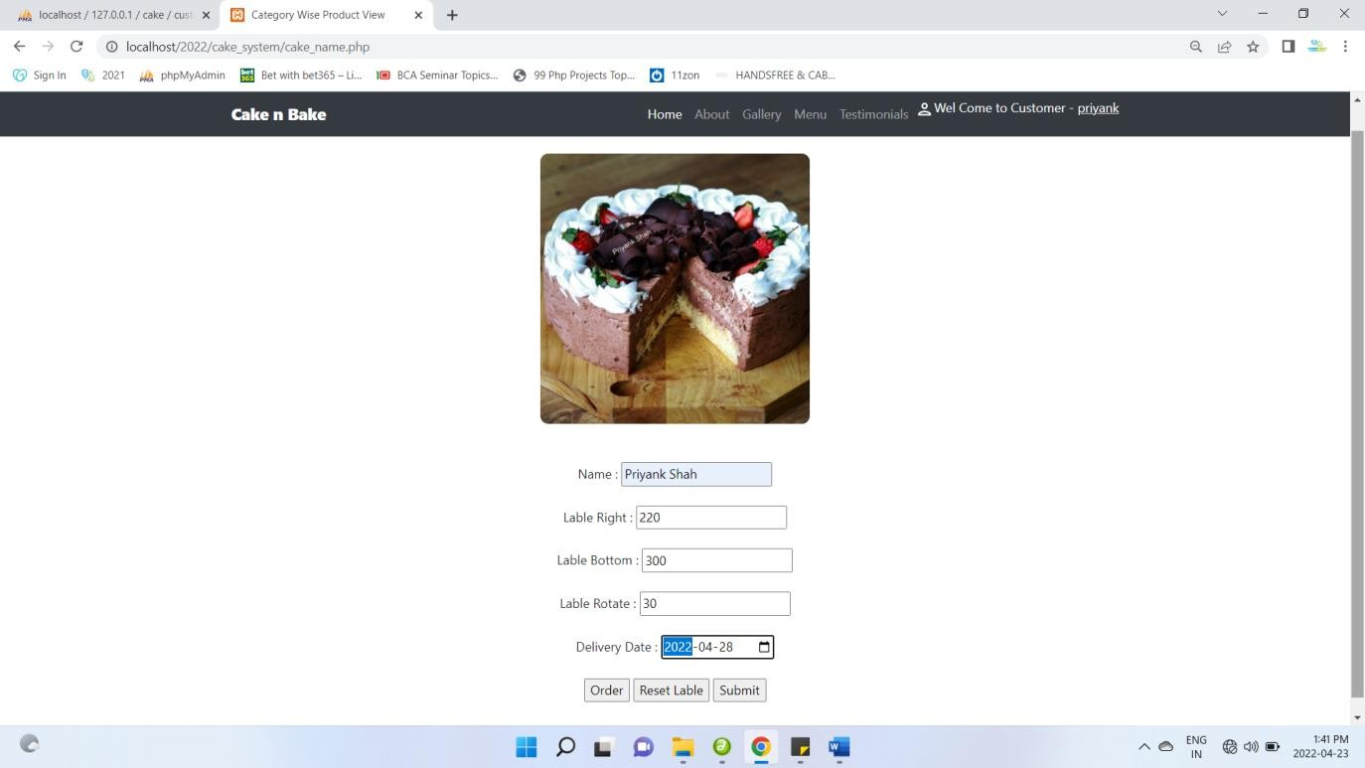

**Order request**

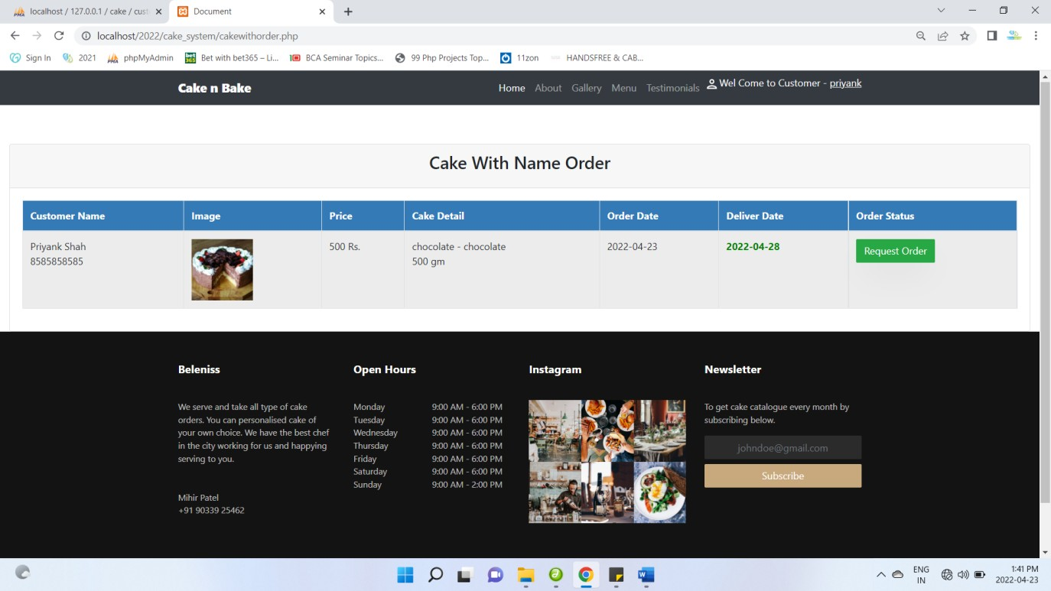

## Admin Accept the request

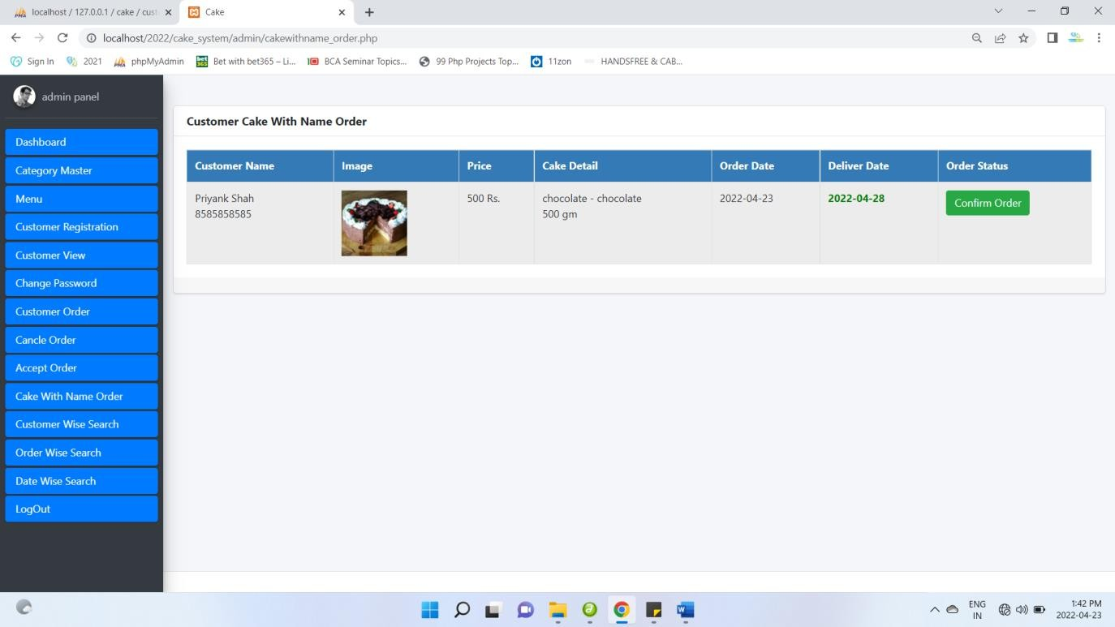

**Order confirm**

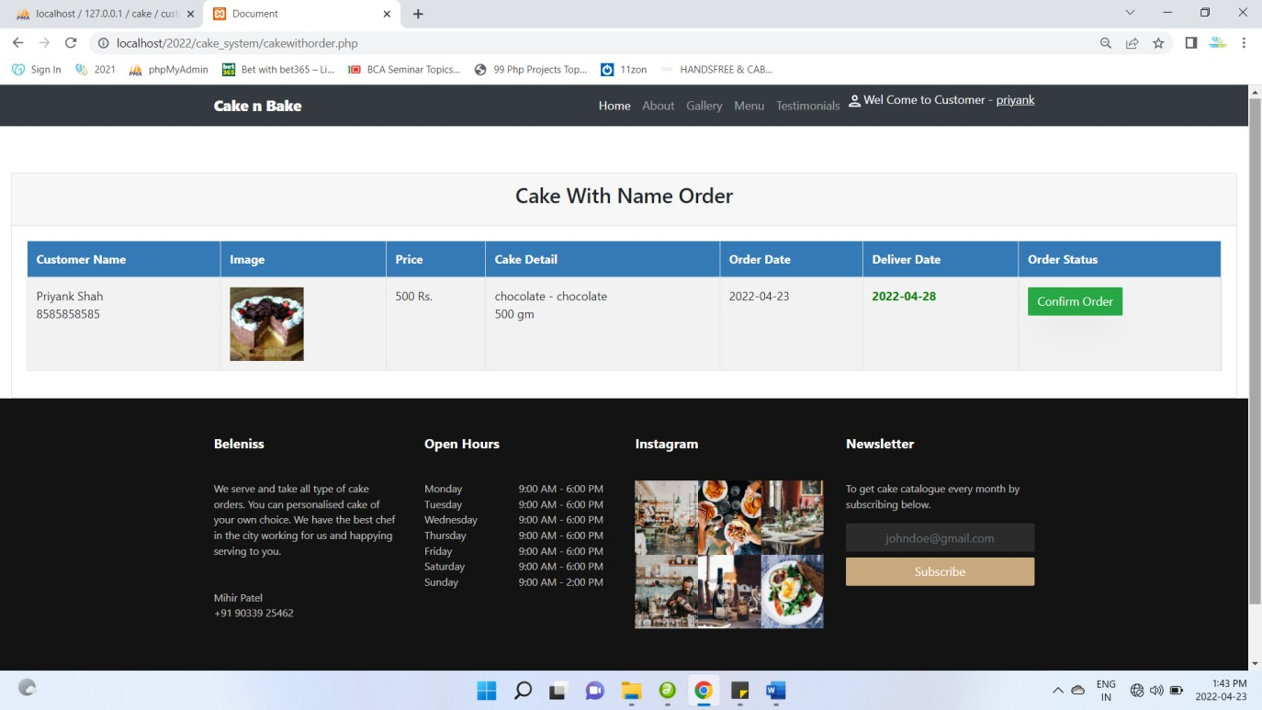

## Customer wise search

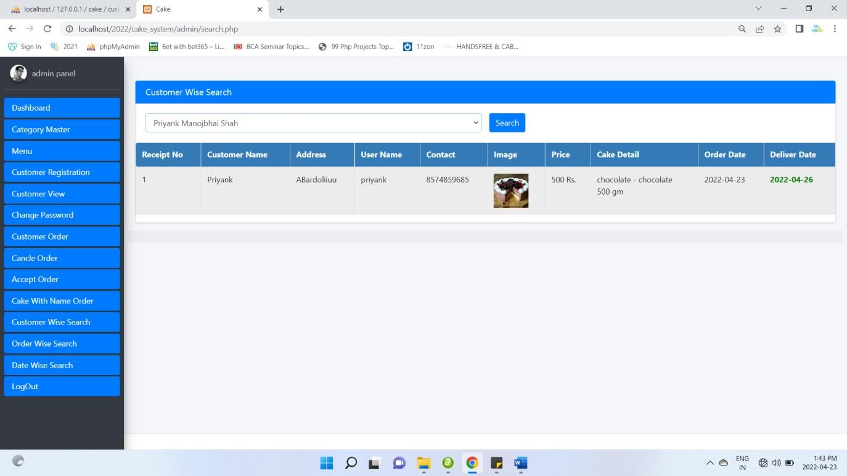

**Order wise search**

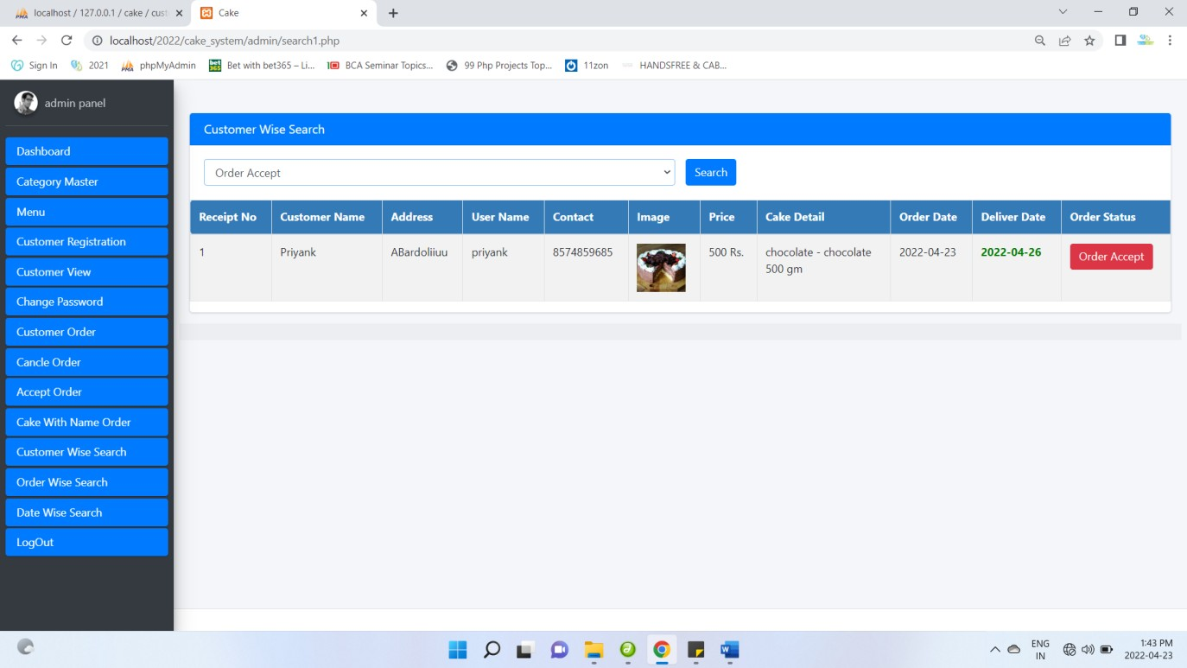

## Date wise search

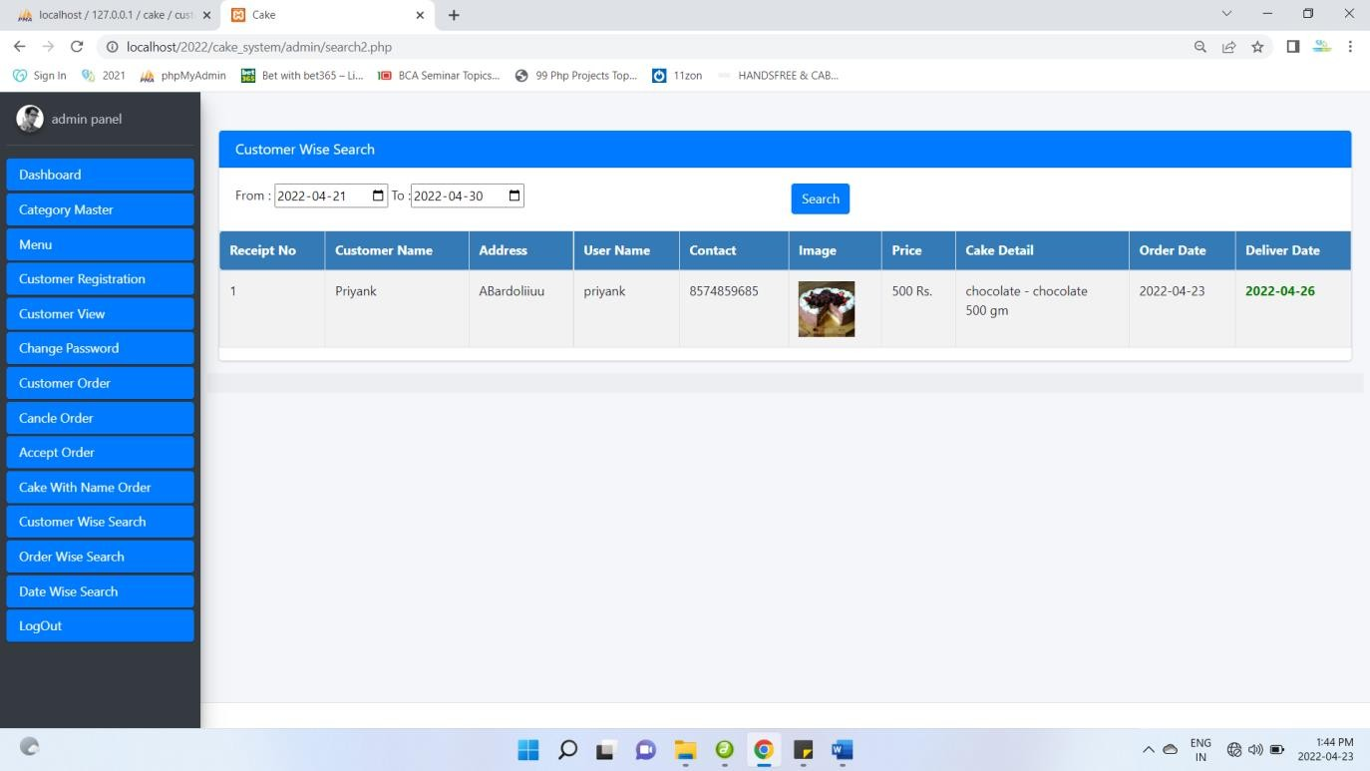

**Validation**

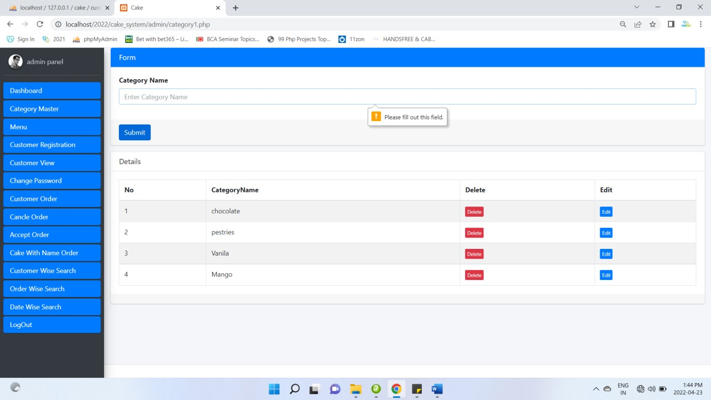

## Only alphabet validation

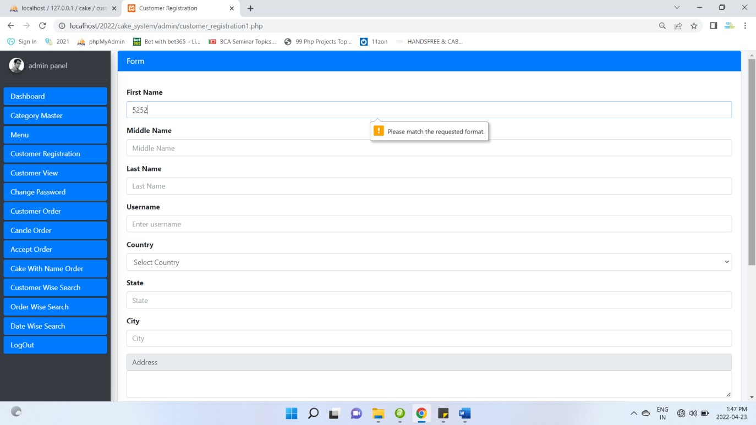

**Mobile 10-digit validation**

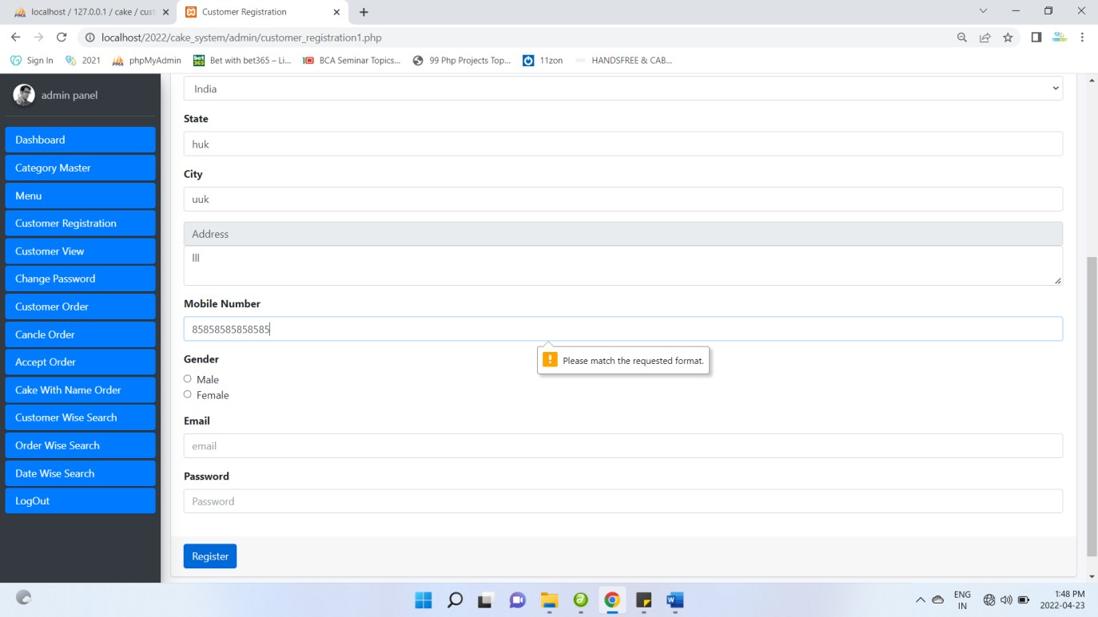

# TESTING

## TESTING PLAN / STRATEGY

After finishing the development of any computer-based system the next complicated time-consuming work is system testing. During the time of testing only the development company can know that, how far the user requirements have been met out, and so on. Following are the some of the testing methods applied to this effective project.

### UNIT TESTING

* Unit testing means the verification and validation of software. In unit testing (is the smallest part of a module); programmer tests each units of source code for fit to use.
* Unit testing focuses on verifying the effort on the smallest unit of software-module.
* The local data structure is examined to ensure that the date stored temporarily maintains its integrity during all steps in the algorithm’s execution.
* Unit Tested area to ensure that the module operates properly at boundaries established to limit.

### INTEGRATION TESTING

* Integration testing takes input as module that means, it is nothing but the set of unit tested module. It collects them in bigger aggregates and implements tests explained in an integration test plan. Afterwards, distribute as its outcomes to the integrated system which is prepared

for system testing.

* In the Integration testing (Modules) the data can be tested across an interface.
* Conducting tests to uncover errors associated with interring while integration testing is a technique for constructing a program structure**.**

### SPECIFICATION TESTING

* We can set with, what program should do and how it should perform under various conditions. This testing is a comparative study of evolution of system performance and system requirements.

### MODULE LEVEL TESTING

* We can design the various modules for any software and each module contains the small part of the code. If the error will be found at any module, then it encourages the programmer tosearch and rectify that

error without disturbing the other modules.

### VALIDATION TESTING

* Tester is the responsible for Validation of each module, and all the tests done in ‘block box’ testing; it will treat as validation testing.
* It begins after the integration testing is successfully assembled.
* If the software functions in a manner of reasonably accepted by the client then and then only the validation succeeds.
* In this the majority of the validation is done during the data entry operation where there is a maximum possibility of entering wrong data and other validation will be performed in all process where correct details and data should be entered to get the required results.

### RECOVERY TESTING

* Testing which defines the way applications recover from hardware failure and crashes which called as activity testing.
* It detects the where the failure of the software is occurred and provide a number of ways recover the failure module and it send the confirmation about the recovery. In process of recovery testing do not be confused with reliability testing because it tries to discover the point at which

failure occurs**.**

### SECURITY TESTING

* It is a procedure to verify that the system maintains and protects data functionality as intended. Some basic security concepts that need to be covered by security testing are: authentication, integrity, availability, confidentiality, non-repudiation and authorization.
* Security testing is mechanisms which restricts it from offensive penetration and verify that protection mechanism.

### PERFORMANCE TESTING

* The usefulness of computer application, network, and devices can be decided by performance testing.
* In the context of integrated testing system, it checks the performance of software at runtime.
* Performance testing can be also used for calculating the characteristics like reliability, scalability and interoperability.
* It is generally used together with stress testing.

### BLACKBOX TESTING

* It focuses on functional requirement of software. It enables to derive input states that will completely implement every one useful requirement for a program.
* Black box testing is used for finding errors in the categories show below:
* It detects the wrong or misplaced functions. Poorly developed interfaces. It is also used for finding errors in data structures or external database access and performance errors.

## TEST RESULTS AND ANALYSIS

* + 1. **TEST CASES (TEST ID, TEST CONDITION, EXPECTED OUTPUT, ACTUAL OUTPUT, REMARK)**

## 7.2.1 Test Plan

|  |  |  |  |  |  |
| --- | --- | --- | --- | --- | --- |
| **Project Name** | **Recruitment**  **analysis & selection process** | **Browser** | **Chrome** |  | |
| **Test**  **Case ID** | **1** | **Test Title:** | **Taking**  **Admin** |
| **Module** | **Category Master** | **Test By:** |  |
| **Test**  **On:** |  | **Priority:** | **High** |
|  | | | | | |
| Test # | Test Steps | Action | Expected  Results | Actual Results | Pass  ? |
| 1 | Navigate/Visit table  Category Page |  | Should open  add Category | Place Category Page  Opened | Yes |
| 2 | Fill up Necessary  Date related to Order | Add necessary data in appropriate  controls | Category  Data is ready to submit | Category Data is ready to submit | Yes |
| 3 | Send Category  Details | Click on Submit  Button | Category  data inserted | Category data  inserted | Yes |

|  |  |  |  |  |  |
| --- | --- | --- | --- | --- | --- |
| **Project Name** | **Recruitment analysis &**  **selection process** | **Browser** | **Chrome** |  | |
| **Test Case ID** | **2** | **Test Title:** | **Taking**  **Menu details** |
| **Module** | **Menu Master** | **Test By:** |  |
| **Test**  **On:** |  | **Priority:** | **High** |
|  | | | | | |
| Test # | Test Steps | Action | Expected  Results | Actual Results | Pass  ? |
| 1 | Navigate/Visit table  Menu Page |  | Should open  Menu page | Menu Page Opened | Yes |
| 2 | Fill up Necessary  Data related to Menu | Add necessary data in appropriate  controls | Menu Data is  ready to submit | Menu Data is ready to submit | Yes |
| 3 | Send Menu Details | Click on Submit  Button | Menu data is  submitted | Menu data inserted | Yes |

|  |  |  |  |  |  |
| --- | --- | --- | --- | --- | --- |
| **Project Name** | **Recruitment analysis &**  **selection process** | **Browser** | **Chrome** |  | |
| **Test Case ID** | **3** | **Test Title:** | **customer**  **registration details** |
| **Module** | **customer**  **registration master** | **Test By:** |  |
| **Test**  **On:** |  | **Priority:** | **High** |
|  | | | | | |
| Test # | Test Steps | Action | Expected  Results | Actual Results | Pass  ? |
| 1 | Navigate/Visit customer  registration Page |  | Should customer registration  page | customer registration Page  Opened | Yes |
| 2 | Fill up Necessary Data related to  registration details | Add necessary data in appropriate  controls | table booking Data is ready  to submit | table booking Data is ready to submit | Yes |
| 3 | Send registration Details | Click on Submit Button | registered data is  submitted | customer registration data is  inserted | Yes |

|  |  |  |  |  |  |
| --- | --- | --- | --- | --- | --- |
| **Project Name** | **Recruitment analysis &**  **selection process** | **Browser** | **Chrome** |  | |
| **Test Case ID** | **4** | **Test Title:** | **Customer**  **order details** |
| **Module** | **Customer Order**  **master** | **Test By:** |  |
| **Test**  **On:** |  | **Priority:** | **High** |
|  | | | | | |
| Test # | Test Steps | Action | Expected  Results | Actual Results | Pass  ? |
| 1 | Navigate/Visit  Customer Order Page |  | Should  Customer Order page | Customer Order Page Opened | Yes |
| 2 | Fill up Necessary Data related to Customer Order  details | Add necessary data in appropriate  controls | Customer Order Data is ready to  submit | Customer Order Data is ready to  submit | Yes |
| 3 | Send Customer Order Details | Click on Submit Button | Customer  Order data is submitted | Customer Order data is inserted | Yes |

|  |  |  |  |  |  |
| --- | --- | --- | --- | --- | --- |
| **Project Name** | **Recruitment analysis &**  **selection process** | **Browser** | **Chrome** |  | |
| **Test**  **Case ID** | **5** | **Test Title:** | **login**  **details** |
| **Module** | **login master** | **Test By:** |  |
| **Test**  **On:** |  | **Priority:** | **High** |
| Test # | Test Steps | Action | Expected  Results | Actual Results | Pass  ? |
| 1 | Navigate/Visit login  Page |  | Should open  login page | login Page Opened | Yes |
| 2 | Fill up Necessary Data login details | Add necessary data in appropriate  controls | login is ready to submit | login Data is ready to submit | Yes |
| 3 | Send login Details | Click on Submit  Button | login data is  submitted | login data is inserted | Yes |

[**Table 7.2.1 Test Plan**]

**CHAPTER 8 CONCLUSION AND DISCUSSION**

## OVERALL ANALYSIS OF INTERNSHIP / PROJECT VIABILITIES

* + - After completion of the group project, from the Week 13 to Week 15; we are supposed to do an individual small project on our domain.
    - I have designed “Task Managing Web Application” using PHP
    - Task management software is used to manage your tasks, help with the estimation and scheduling, track dependencies, resources and milestones and help you make decisions when changes in priority are needed. Under the web development, the field supervisor overviewed basic understanding of web technologies (HTML, CSS, PHP) using database MYSQL.

## DATES OF CONTINUOUS EVALUATION

It is an extremely wonderful moment while I am concluding this report. This is my first experience to perform such professional work. Objective of this project was to satisfy user’s requirement, successful implementation of the system, design a user friendly and easy to operate system.

I have the opportunity to learn about Academic centre activities and management. Conceptually and practical knowledge of software engineering, system analysis, system design and real time experience of the project implementation PHP in front end and My SQL database as back end.

At last I am very thankful to the Gujarat Technological University Ahmadabad to include this project. Work as part of our BE. This project work really Gives chance to earn something out of typical reference books.

## SUMMARY OF INTERNSHIP / PROJECT WORK

|  |  |  |
| --- | --- | --- |
| **Milestone** | **Milestone Description** | **Date** |
| 1. | Literature review | 25/01/2022 |
| 2. | Requirement Gathering and Analysis | 12/02/2022 |
| 3. | Design | 27/02/2022 |
| 4. | Implementation | 19/03/2022 |
| 5. | Testing | 08/04/2022 |

* 1. **LIMITATION AND FUTURE ENHANCEMENT**

### LIMITATION

* + - * Cannot provide online payment Facility.

### FUTURE ENHANCEMENT

* + - * The systems enhance our customer module in that we try to add online food order facility.
      * In this system we will accept the payments through the net banking/card/UPI.
      * In this system we will provide notification to user before one hour cake order time by enhancing SMS Messages module.

**CHAPTER 9: BIBLIOGRAPHY**

## Web Site:

* <https://www.w3schools.com/>
* <http://www.php.net/>
* <http://www.phppoint.com/>
* <https://www.goodreads.com/>

## Books:

* + PHP and My SQL Web Development
  + The Complete Reference
  + Web Technologies